**Networking Tutorial**

* **5 layer network model:**

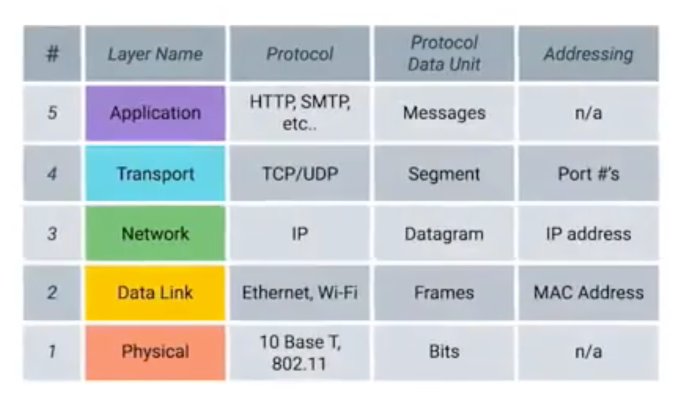

**Physical Layer:**

Represents the physical devices that interconnect computers.

**Data Link Layer:**

Also called as network interface layer or network access layer.

Responsible for defining a common way of interpreting these signals so network devices can communicate.

Protocol for Data Link Layer is Ethernet.

The Ethernet standards also define a protocol responsible for getting data to nodes on the same network or link.

**Network Layer:**

Also called as internet layer.

Allows different networks to communicate with each other through devices known as routers.

Internetwork:

A collection of networks connected together through routers, the most famous of these being the Internet.

Protocol:

IP or Internet Protocol

IP is the heart of the Internet and most smaller networks around the world.

**Transport Layer:**

Sorts out which client and server programs are supposed to get that data.

Protocol: TCP & UDP

TCP – ensures message reliability of data delivery.

UDP – doesn’t ensure reliability of data delivery.

**Application Layer:**

**Overall Flow:**

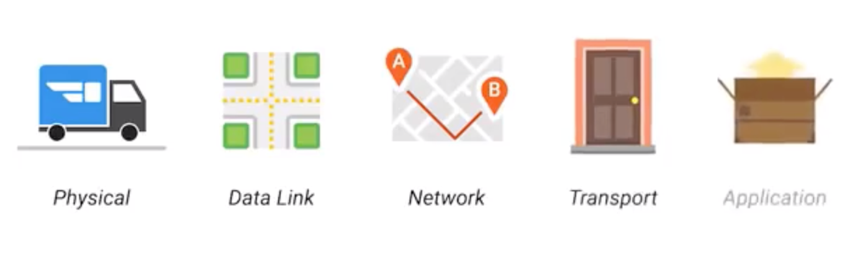

**TCP Layering In Detail:**

**Application Layer:**

The application layer is where applications requiring network communications live. Examples of these applications include email client and web browsers.

These applications use the Transport Layer to send requests to connect to remote hosts.

**Transport Layer:**

This layer establishes the connection between applications running on different hosts.

It uses TCP for reliable connection and UDP for fast connections.

It keeps track of the processes running in the applications above it by assigning port numbers to them and uses Network layer to access the TCP/IP network.

**Network Layer:**

The Network Layer is responsible for creating the packets that move across the network. It uses the IP addresses to identify the packet’s source and destination.

**Data Link Layer:**

This layer is responsible for creating the frames that move across the network. These frames encapsulates the packets and MAC addresses to identify the source and destination.

**Physical Layer:**

This layer encodes and decodes the bits found in a frame and includes the transceiver that drives and receives the signals on the network.

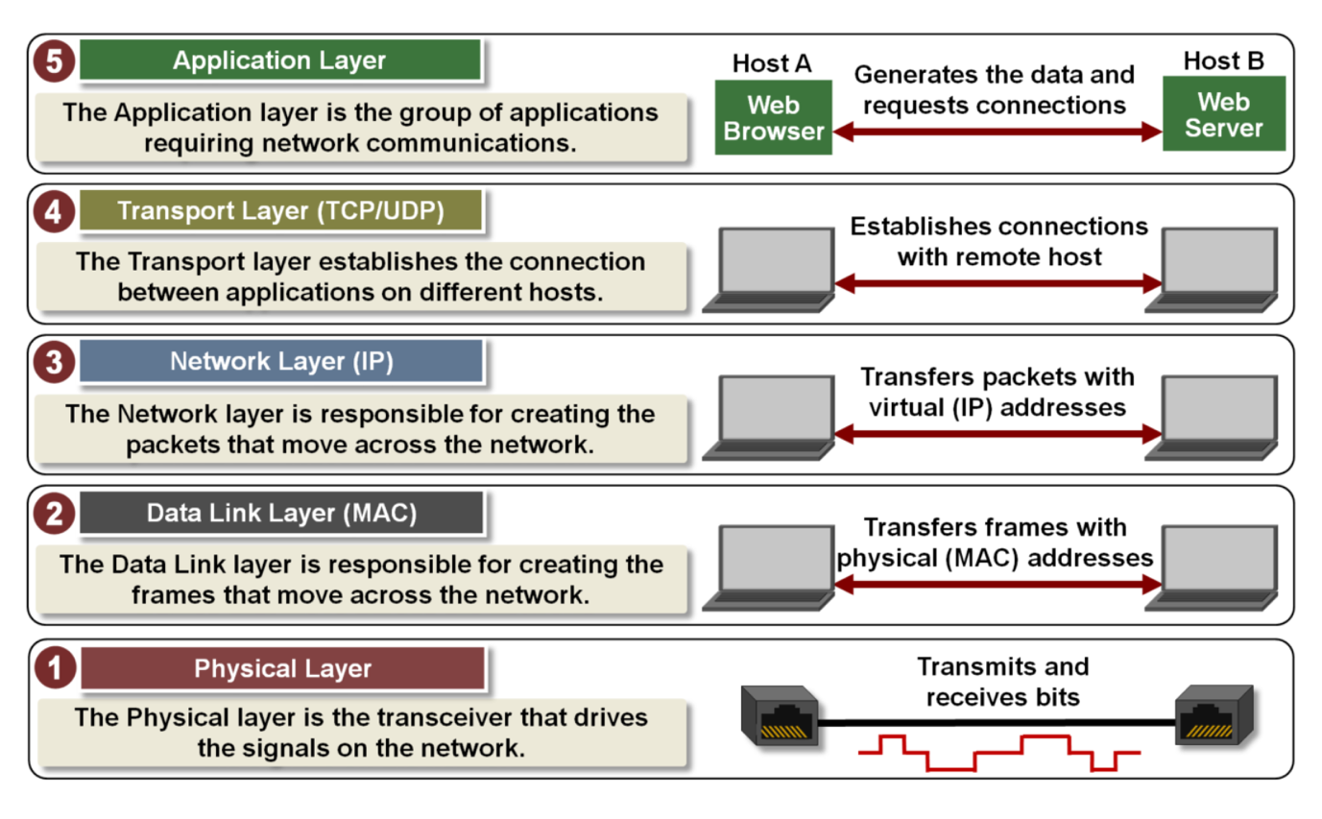

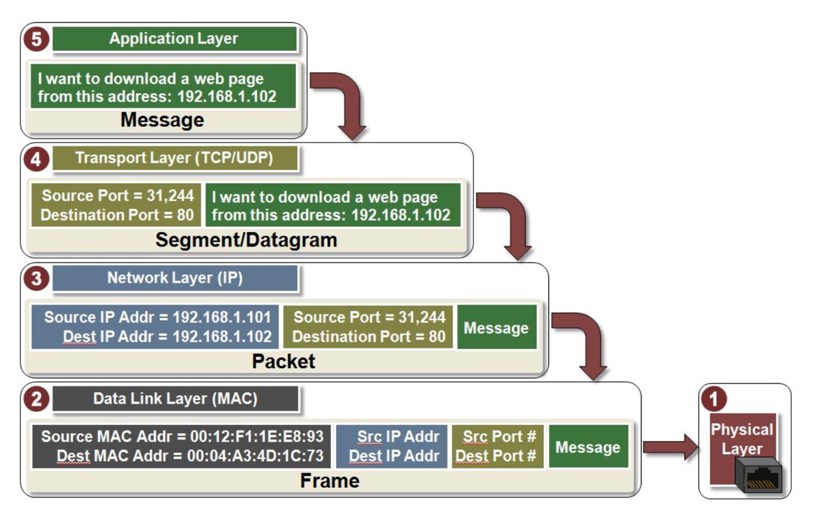

* **Networking Devices:**

**Cables:**

Connect different devices to each other, allowing data to be transmitted over them.

Types: Copper and Fiber.

The most common forms of copper twisted-pair cables used in networking are Cat5, Cat5e, and Cat6 cables.

Crosstalk:

When an electrical pulse on one wire is accidentally detected on another wire.

Fiber cables:

Contain individual optical fibers, which are tiny tubes made out of glass about the width of human hair.

**Hubs and Switches:**

Hub:

A physical layer device that allows for connections from many computers at once.

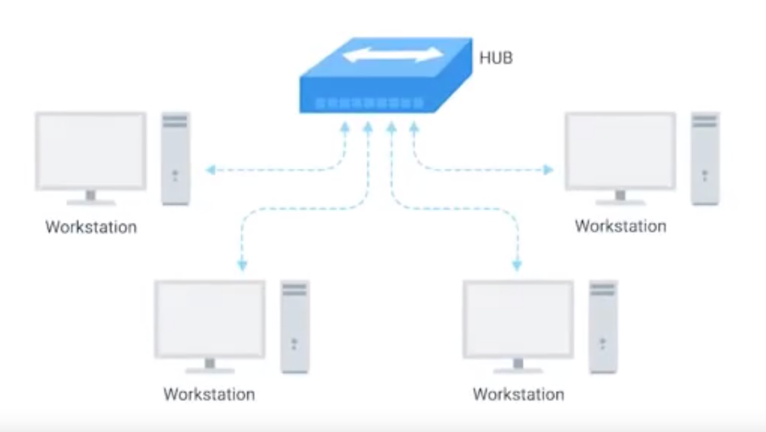

Collision domain:

A network segment where only one device can communicate at a time.

If multiple systems try sending data at the same time, the electrical pulses sent across the cable can interfere with each other.

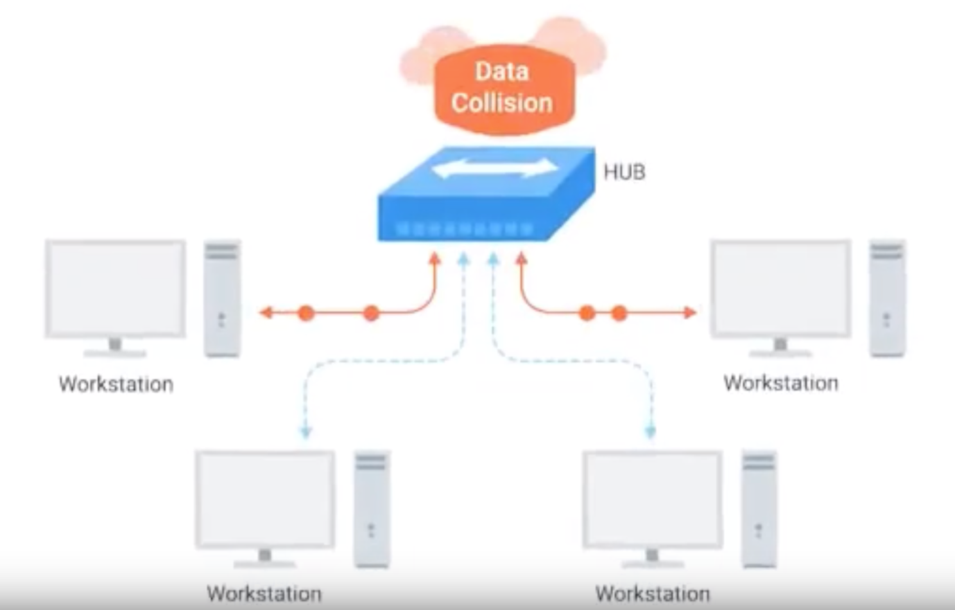

Switch:

Switch is very similar to hub, we can connect many computer to it.

The difference is that, the hub works on Physical layer, whereas Switch works on Data Link layer.

Switch can send data to the specific / intended recipient, thus reducing the collision domain.

**Routers:**

Hubs and Switches:

The primary devices used to connect computers on a single network, usually referred to as LAN, or Local Area Network.

Routers:

A device that knows how to forward data between independent networks.

Router works on Network layer.

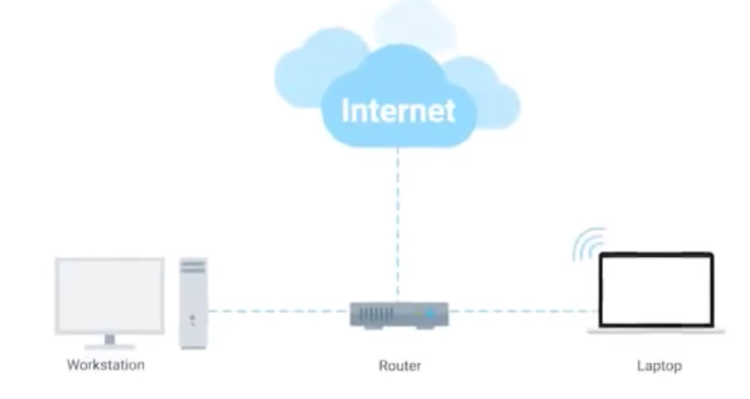

Router stores internal table containing information about how to route traffic between lots of different network all over the world.

Most common router is home or small office, these devices generally don’t have routing tables.

The main work of this kind of router is to take the request inside the network (home or office) and forward it to ISP (Internet Service Provider).

Once the traffic is at ISP, another advanced router takes care of forwarding the traffic. These core routers are back bones of internet, and responsible for sending and receiving traffic every day.

Core router not only deals with routing the request, it will collect the details of other routers in the network.

BGP (Border Gateway Protocol)

Routers share data with each other via this protocol, which lets them learn about the most optimal paths to forward traffic.

* **Moving Bits Across the Wire:**

**Bit:**

The smallest representation of data that a computer can understand; it’s one or zero.

**Modulation:**

A way of varying the voltage of this charge moving across the cable.

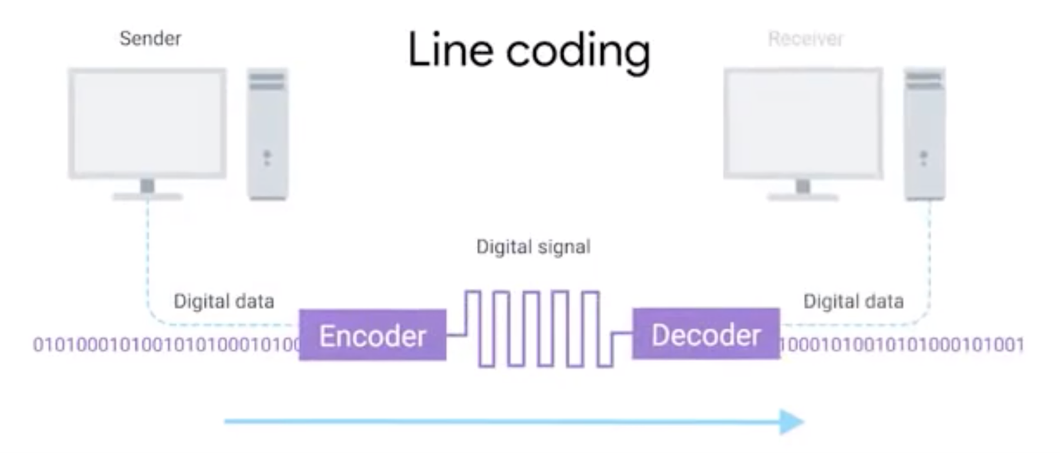

**Twisted Pair Cabling and Duplexing:**

**Duplex communication:**

The concept that information can flow in both directions across the cable.

Example: A phone call, both the party can talk and listen simultaneously.

**Simplex communication:**

This process is unidirectional.

Example: Desktop client sending data to a server.

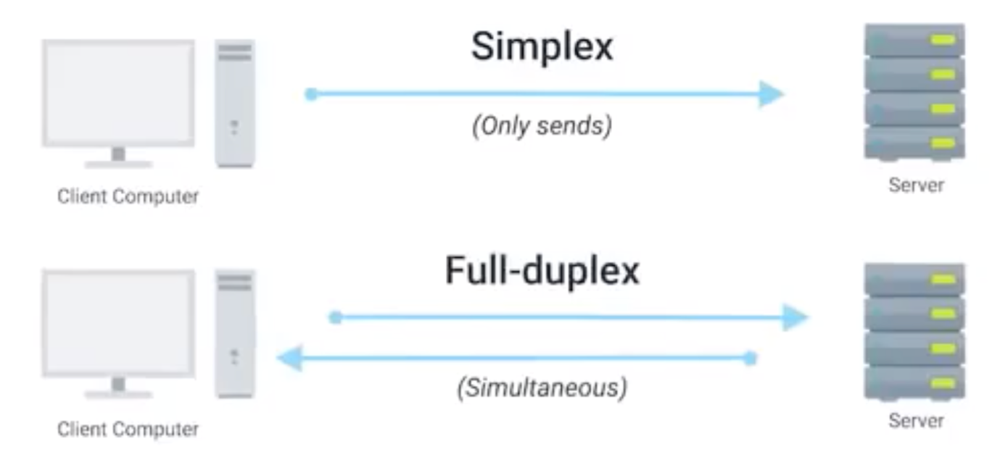

**Full Duplex:**

Both the person can talk and listen simultaneously.

**Half Duplex:**

Only one person can talk and listen.

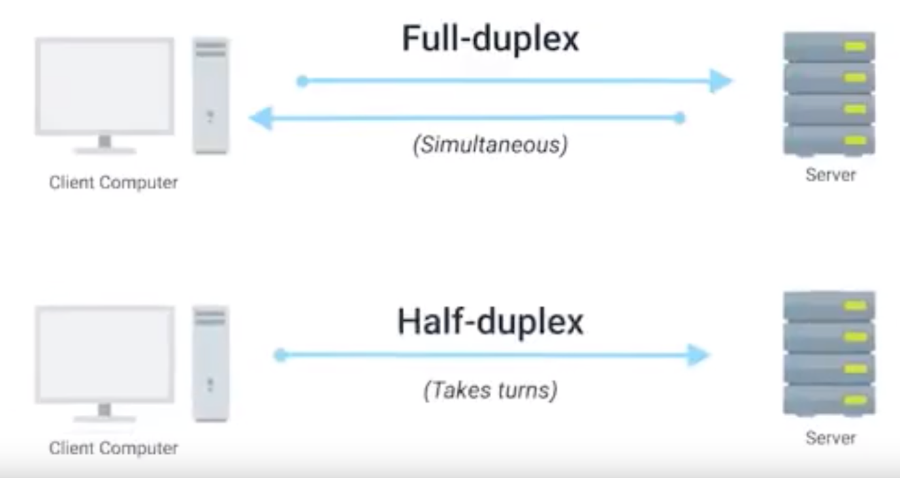

**Network Ports and Patch Channels:**

The endpoint of twisted pair cables terminated with a plug that takes the individual internal wires and exposes them. The most common plug is RJ45 (Registered Jacket45)

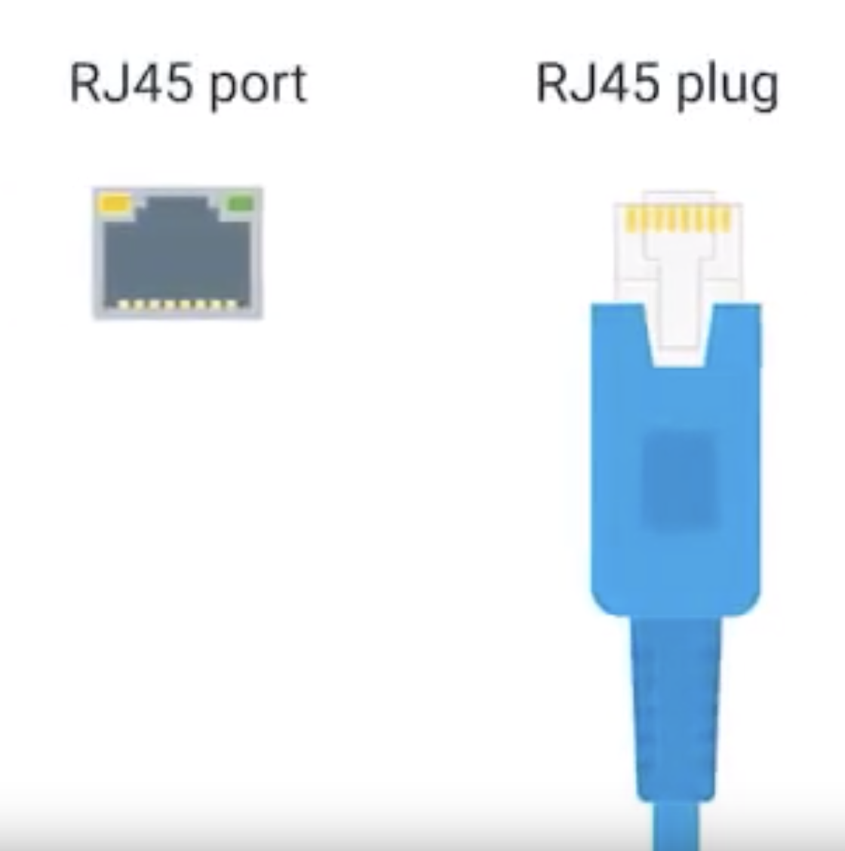

RJ45 plug connects to the RJ45 port.

**Network Ports:**

Network ports are generally directly attached to the devices that make up a computer network.

Switches would have many ports as it has to connect to many systems, whereas laptop or desktop will have one or two ports.

Most network port will have two LED. Link LED and Activity LED.

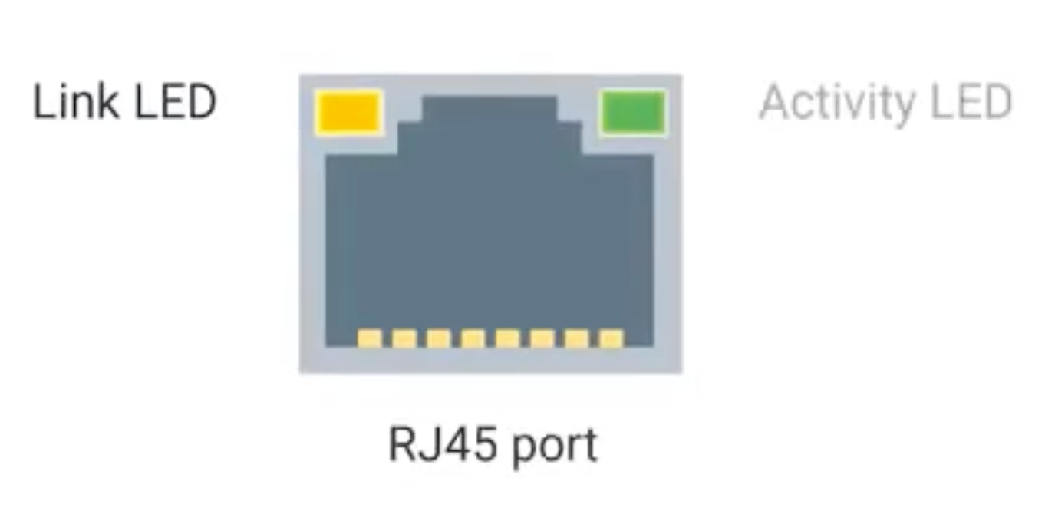

Link LED will flashed if two devices connected properly and powered on.

Activity LED will be flashed when data is actively transmitted across the cable.

Sometimes network port isn’t directly connected to a device, instead network ports mounted in a wall or underneath your desk. Then the ports are connected to patch panel.

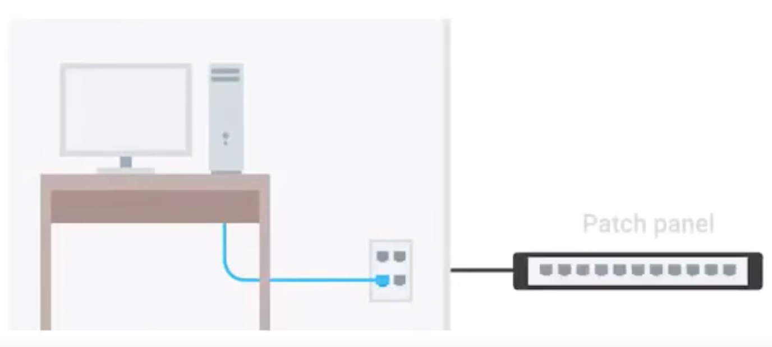

Patchpanel is a device containing many network ports but it doesn’t know how to work. It is just a container for the endpoint.

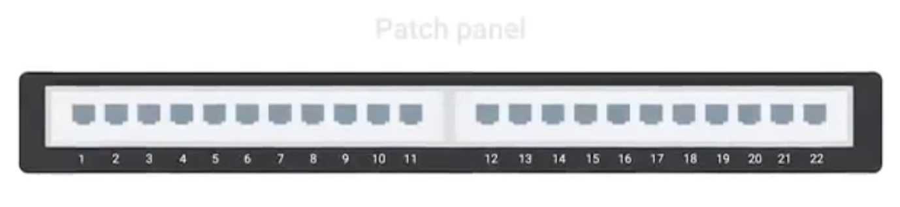

From patch panel the cables are connected to switches or routers. Which provides access to the computers or the servers at other end.

**Ethernet and MAC Addresses:**

Carrier Sends Multiple Access with Collision Detection.

CDMA/CD

Used to determine when the communications channels are clear, and when a device is free to transmit data.

MAC Address:

A globally unique identifier attached to an individual network interface.

It’s a 48-bit number normally represented by six groupings of two hexadecimal numbers.

Hexadecimal:

A way to represent numbers using 16 digits.

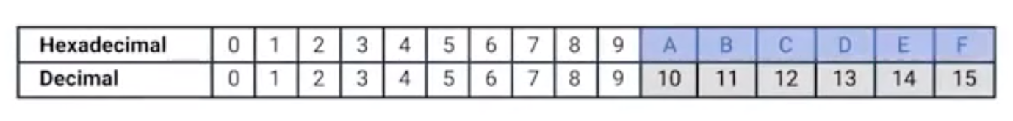

Octet:

In computer networking, any number that can be represented by 8 bits.

Organizationally Unique Identifier (OUI)

The first three octets of a MAC address.

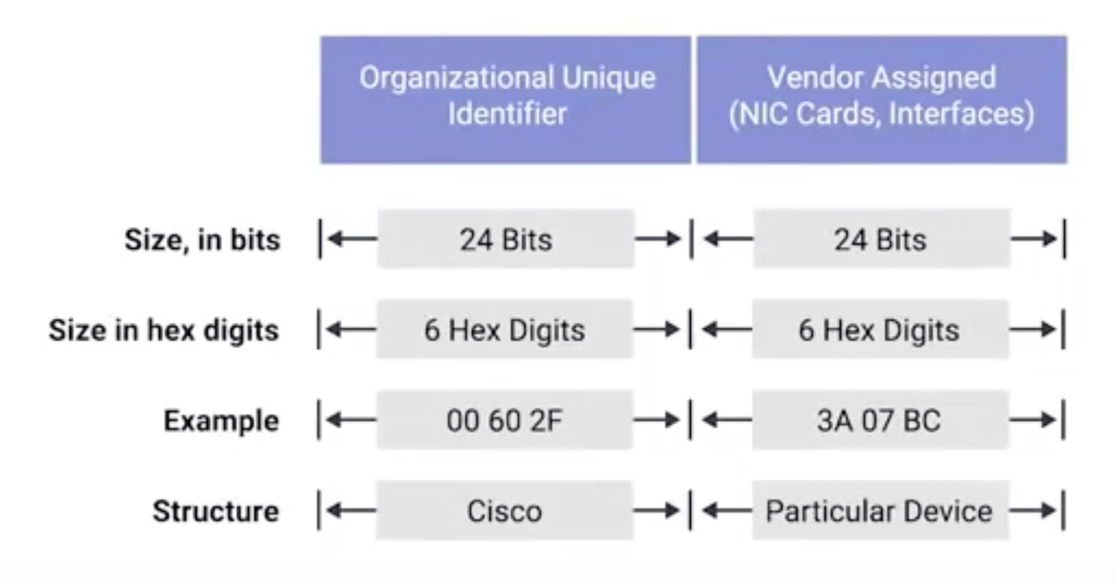

Ethernet uses MAC addresses to ensure that the data it sends has both an address for the machine that sent the transmission, as well as the one the transmission was intended for.

**Unicast, Multicast and Broadcast:**

All these (unicast, multicast and broadcast) comes under ethernet transmission.

One device transmits data to another device – is called Unicast

A unicast transmission is always meant for just one receiving address.

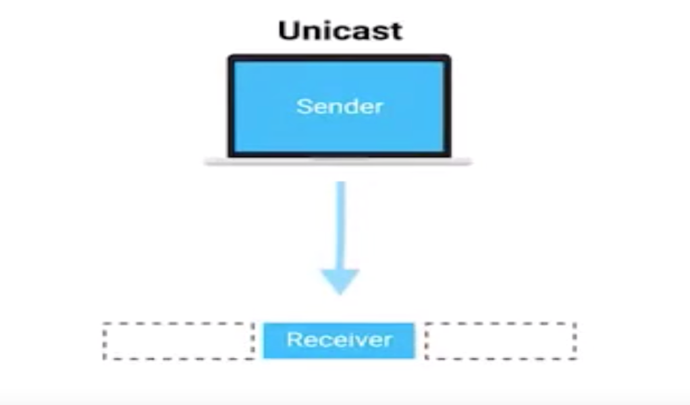

If the least significant bit in the first octet of a destination address is set to zero, it means that ethernet frame is intended for only the destination address.

If the least significant bit in the first octet of a destination address is set to one, it means you are dealing with a multicast frame.

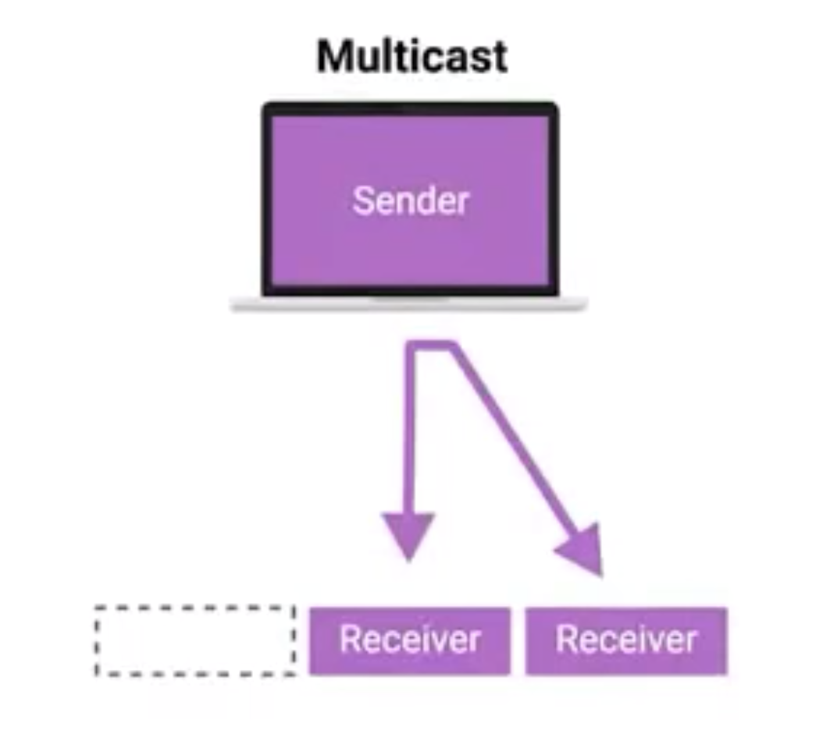

**Broadcast:**

It sends every single device on a LAN.

This is accomplished by a special destination called broadcast address.

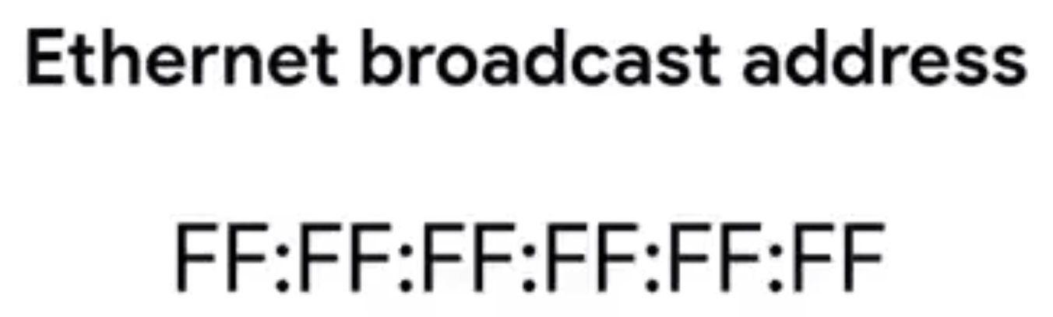

**Dissecting an ethernet frame:**

**Data Packet:**

An all-encompassing term that represents any single set of binary data being sent across a network link.

Note: Data packet is not associated to any layer, its common term.

**Ethernet Frame:**

A highly structured collection of information presented in a specific order.

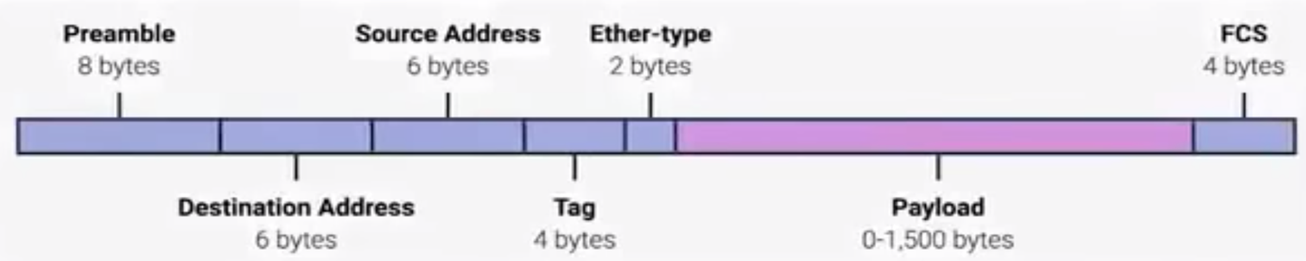

Preamble:

8 bytes (or 64 bits) long, and can itself be split into two sections.

Start frame delimiter:

Signals to a receiving device that the preamble is over and that the actual frame contents will now follow.

Destination Mac Address:

The hardware address of the intended recipient.

Source Mac Address:

Mac address of the host/system sending the frame.

Ether Type Field:

16 bits long and used to describe the protocol of the contents of the frame.

VLAN Header:

Indicates that the frame itself is what’s called a VLAN frame.

If a VLAN header is present, the Ether Type fields follow it.

Virtual LAN (VLAN):

A technique that lets you have multiple logical LANs operating on the same physical equipment.

Payload:

In networking terms, is the actual data being transported, which is everything that isn’t a header.

Frame Check Sequence:

A 4-byte ( or 32-bit) number that represents a checksum value for the entire frame.

This checksum value is calculated by performing what’s known as a cyclical redundancy check against the frame.

Cyclical Redundancy Check:

An important concept for data integrity, and is used all over computing, not just network transmissions.

Once the data reaches the destination, it derives the check sum, it has to match with what had come from the destination, if both are different then the destination system won’t accept the data.

* **The Network Layer:**

**IP Addresses:**

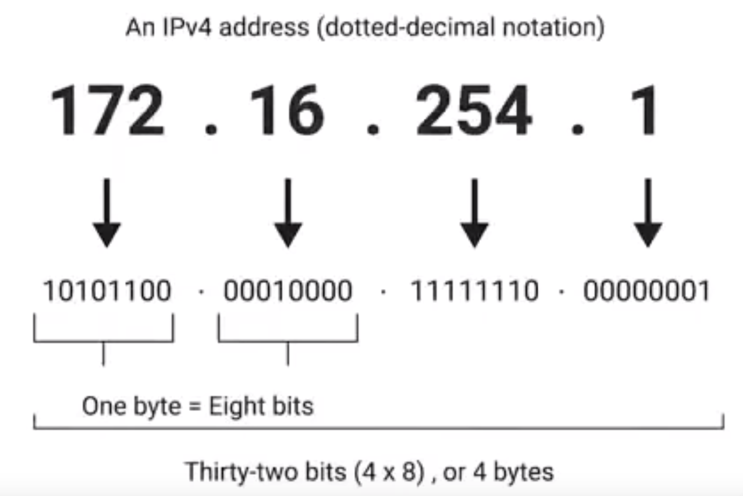

For example, 12.34.56.78 is a valid IP address, but 123.456.789.100 would not be, because it has numbers larger than could be represented by 8 bits.

IP addresses belongs to networks, not to the devices attached to those networks.

In modern network, whenever we connect a new device an IP address is assigned automatically known as DHCP (Dynamic Host Configuration Protocol).

The IP addressed assigned this way is called dynamic IP. The opposite of this is known as static IP address which must be configured on a node manually.

In most cases, the static IP addresses are reserved for servers and network devices, while dynamic IP addresses are reserved for clients.

**IP Datagrams and Encapsulation:**

**IP Datagram:**

A highly structured series of fields that are strictly defined.

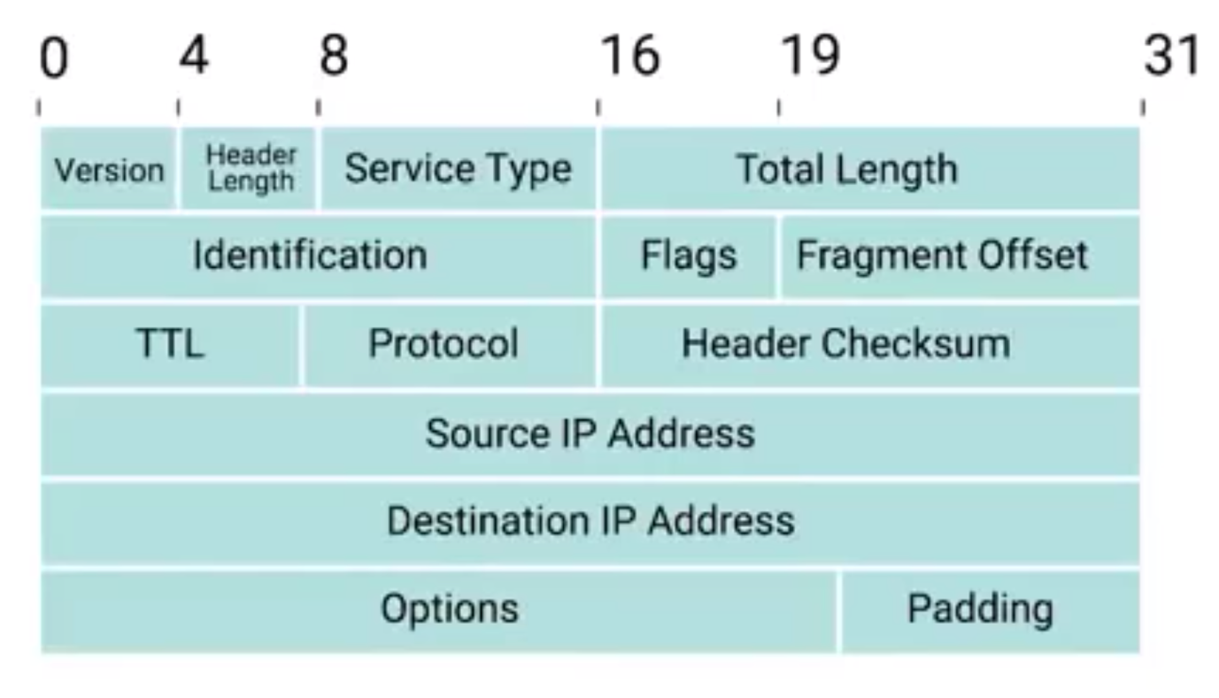

Version:

The most common version of IP is version 4 or IPv4

Header Length Field:

Almost always 20 bytes in length when dealing with IPv4.

Service Type Field:

These 8bits can be used to specify details about quality of service, or QoS, technologies.

Total Length Field:

Indicates the total length of the IP datagram its attached to.

Identification Field:

A 16-bits number that’s used to group messages together.

The maximum size of a single datagram is the largest number you can represent with 16bits. 65, 535

If the total amount of data that needs to be sent is larger that what can fit in a single datagram, the IP layer needs to split this data up into many individual packets.

Flag field:

Used to indicate if a datagram is allowed to be fragmented, or to indicate that the datagram has already been fragmented.

Fragmentation:

The process of taking a single IP datagram and splitting it up into several smaller datagrams.

Time to live (TTL) field:

An 8-bit field that indicates how many router hops a datagram can traverse before it’s thrown away.

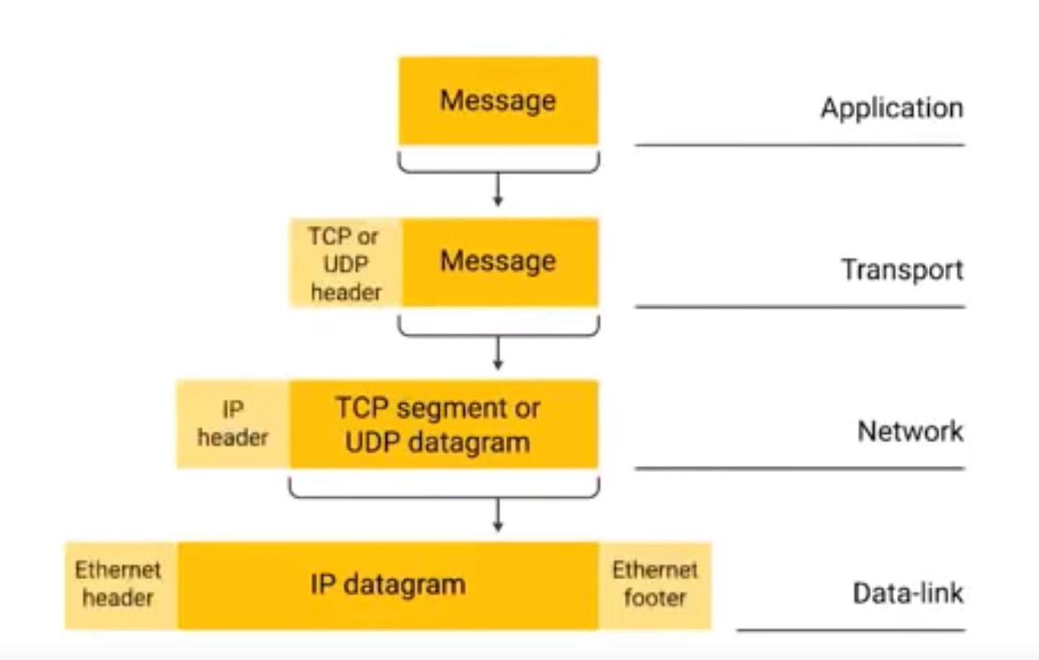

**IP Address Classes:**

IP addresses can be split into two sections:

The network ID and the host ID.

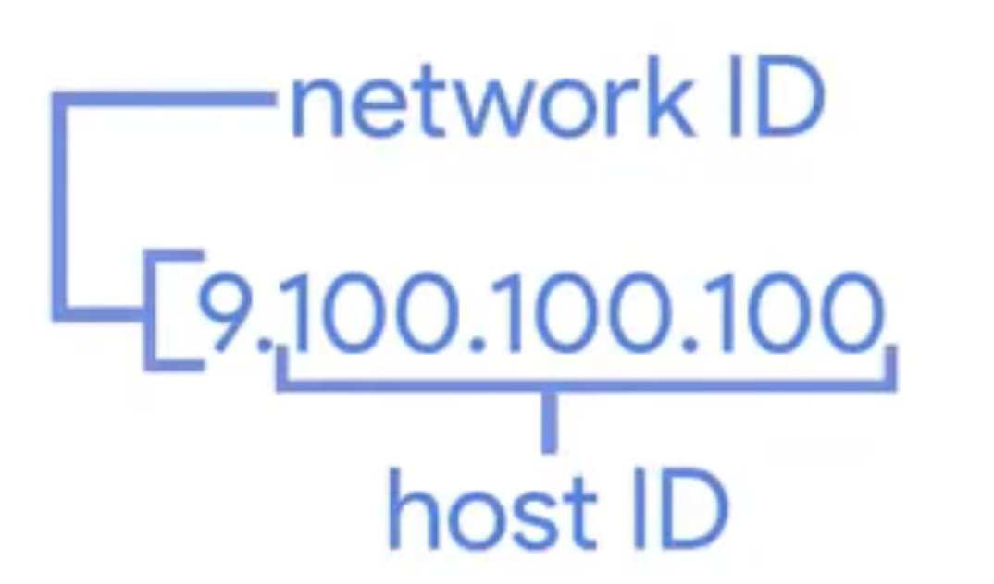

**Address Class System:**

A way of defining how the global IP address space is split up.

Class – A: First octet is used for network id

Class – B: First and second octet used for network id

Class – C: First three octets are used for network id.

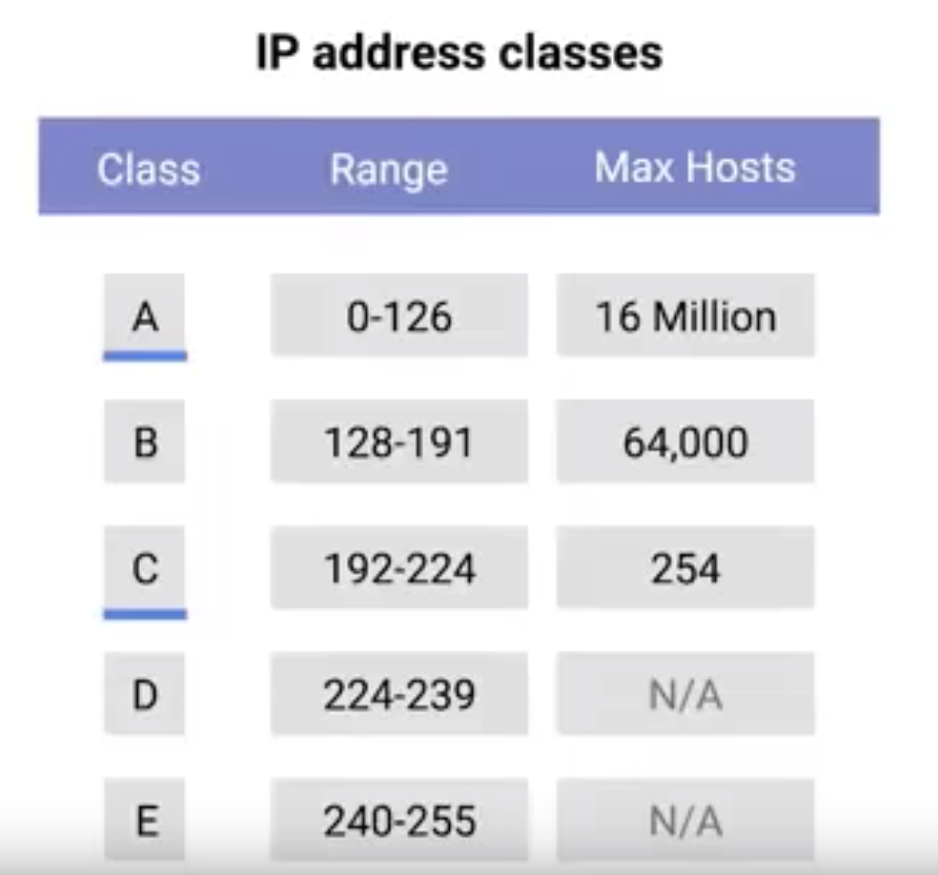

**Address Resolution Protocol:**

A protocol used to discover the hardware address of a node with a certain IP address.

ARP table:

A list of IP addresses and the MAC addresses associated with them.

If a host (10.20.30.40) wants to send a message, first time the ARP table will not have any information.

The host will send a ARP message to the broadcast MAC address (FF:FF:FF:FF:FF) to all the hosts

As a response all host will send their MAC address.

ARP table entries generally expire after a short amount of time to ensure changes in the network are accounted for.

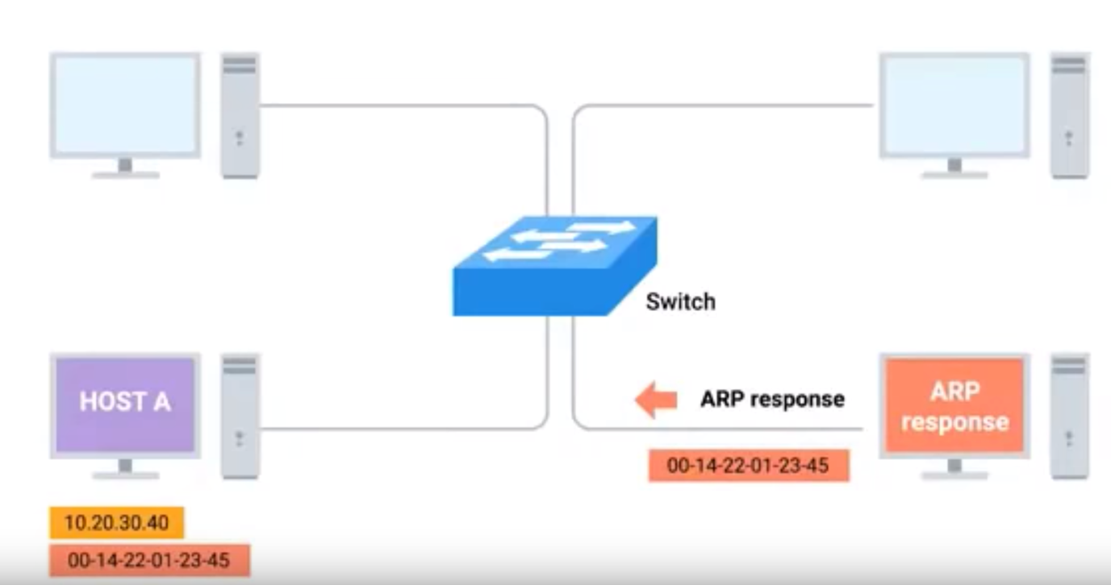

**Subnetting:**

The process of taking a large network and splitting it up into many individual and smaller subnetworks, or subnets.

Subnet Id:

**What is subnetting?**

Subnetting is the process of dividing a single large network in multiple smaller networks.

A single network is like a town without any sector and street address. In such a town, a postman may take 3 to 4 days in finding a single address. While if town is divided in sectors and streets, he can easily find any address in less than one hour.

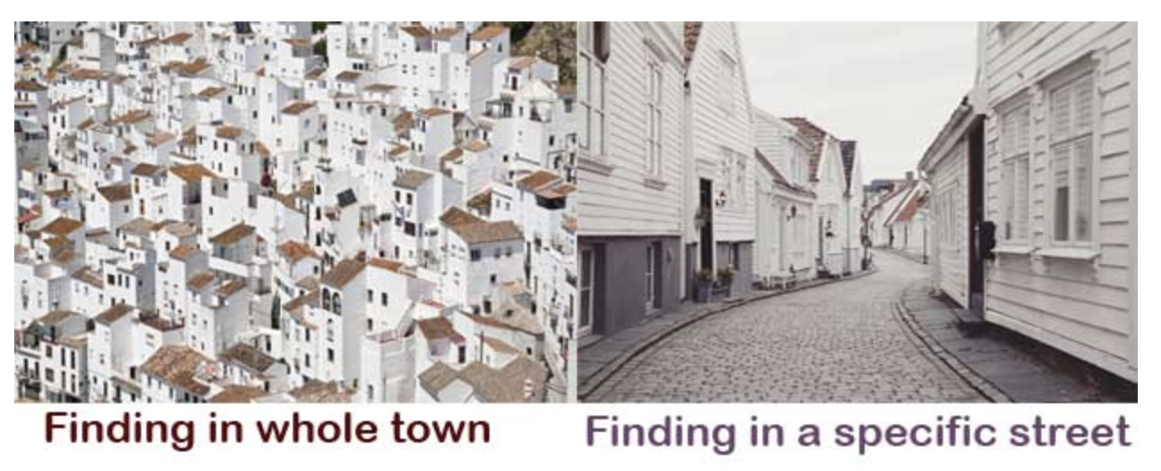

Let’s take another example. Due to maintenance there is a scheduled power cut. If town is divided into sectors, electronic department can make a local announcement for the affected sector rather than making an announcement for the whole town.

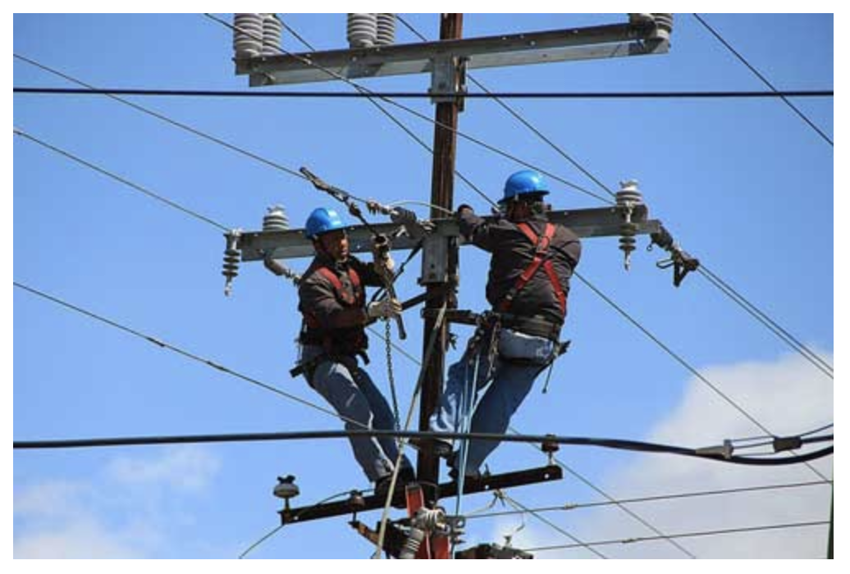

Computer networks also follow the same concept. In computer networking, Subnetting is used to divide a large IP network in smaller IP networks known as subnets.

A default class A, B and C network provides 16777214, 65534, 254 hosts respectively. Having so many hosts in a single network always creates several issues such as broadcast, collision, congestion etc.

Let’s take a simple example. In a company there are four departments; sales, production, development, and management. In each department there are 50 users.

Company used a private class C IP network. Without subnetting, all computers will work in a single large network.

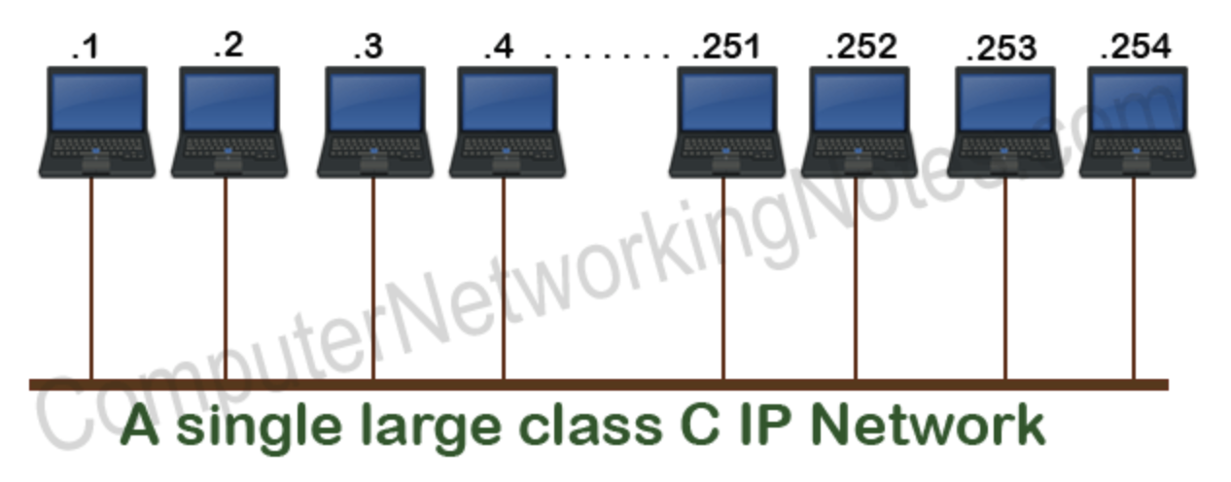

Computers use broadcast message to access and provide information in network.

In this example since all computers belong to same network, they will receive all broadcast messages regardless the broadcast messages which they are receiving are relevant to them or not.

Just like town is divided into sectors, this network can also be divided in subnets. Once network is divided in subnets, computers will receive only the broadcasts which belong to them.

Since company has four departments, it can divide its network in four subnets. As shown below.

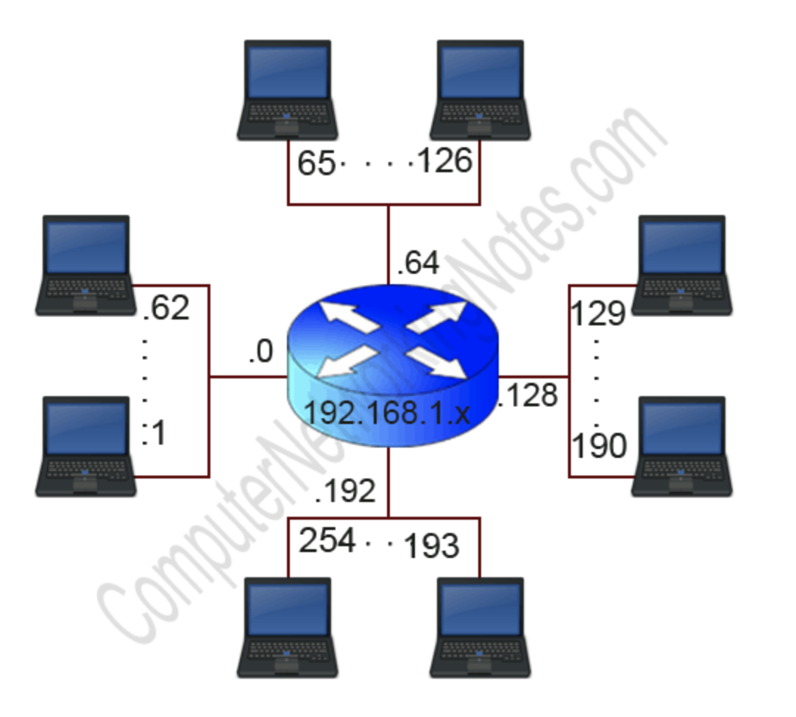

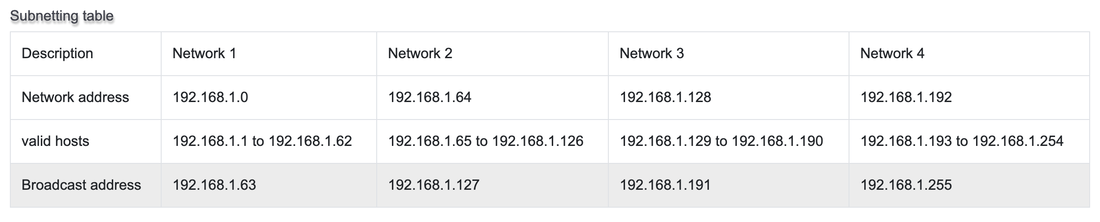

Advantages of Subnetting:

Subnetting allow us to break a single large network in smaller networks. Small networks are easy to manage.

Subnetting reduces network traffic by allowing only broadcast traffic which is relevant to the subnet.

By reducing unnecessary traffic, subnetting improves overall performance of the network.

By blocking a subnet’s traffic in a subnet, Subnetting increases security of the network.

Subnetting reduces the requirement of IP range.

Disadvantages of Subnetting:

Different subnets need an intermediate device known as router to communicate with each other.

Since each subnet uses its own network address and broadcast address, more subnets means more wastage of IP address.

**Address:**

The unique number ID assigned to one host or interface in a network.

**Subnet:**

A portion of a network that shares a particular subnet address.

**Subnet Mask:**

A 32-bit combination used to describe which portion of an address refers to the host.

**Interface:**

A network connection.

**Network Masks:**

A network mask helps you know which portion of the address identifies the network and which portion of the address identifies the node.

Class A, B and C networks have default masks, also known as natural mask.

Class A: 255.0.0.0

Class B: 255.255.0.0

Class C: 255.255.255.0

An IP address on a Class A network that has not been sub netted would have an address/mask pair similar to 8.20.15.1 255.0.0.0

In order to see how the mask helps you identify the network and node parts of the address, convert the address and mask to binary numbers.

8.20.15.1 = 00001000.00010100.00001111.00000001

255.0.0.0 = 11111111.00000000.00000000.00000000

Any address bits which have corresponding mask bits set to 1 represent the network ID. Any address bits that have corresponding mask bits set to 0 represent the node ID.

8.20.15.1 = 00001000.00010100.00001111.00000001

255.0.0.0 = 11111111.00000000.00000000.00000000

-----------------------------------

net id | host id

netid = 00001000 = 8

hostid = 00010100.00001111.00000001 = 20.15.1

**Routing:**

**Basic Routing Concepts:**

**Router:**

A network device that forwards traffic depending on the destination address of that traffic.

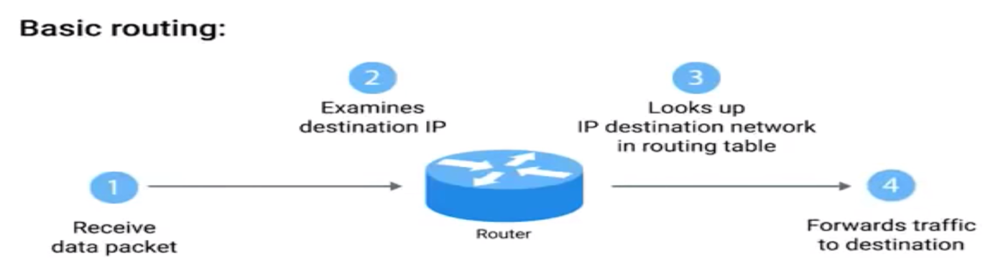

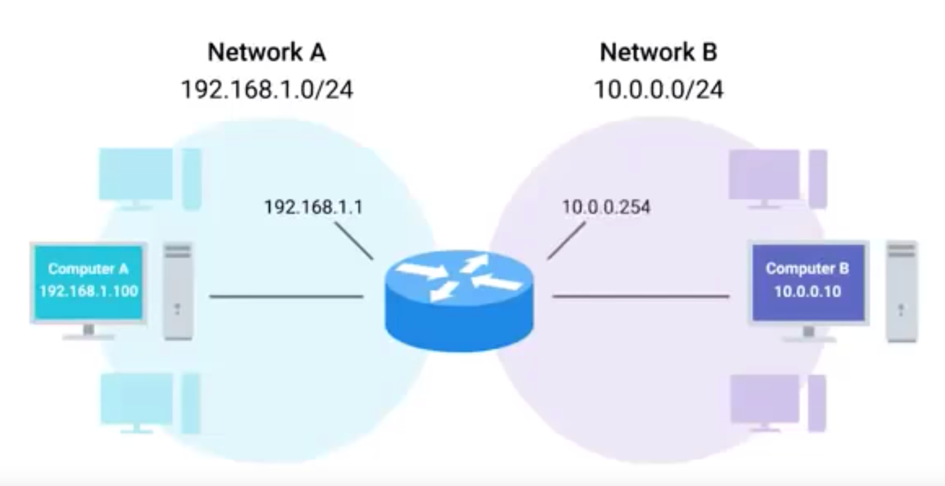

Note: IP addresses belongs to the networks not to the individual nodes on the network.

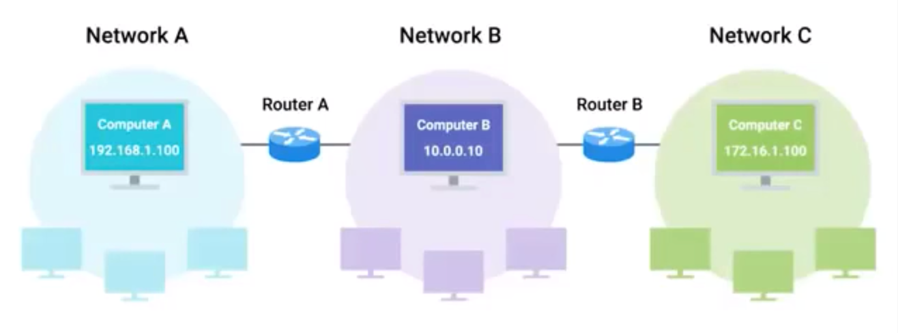

**Routing Tables:**

All routing table will have the following four columns.

Destination network.

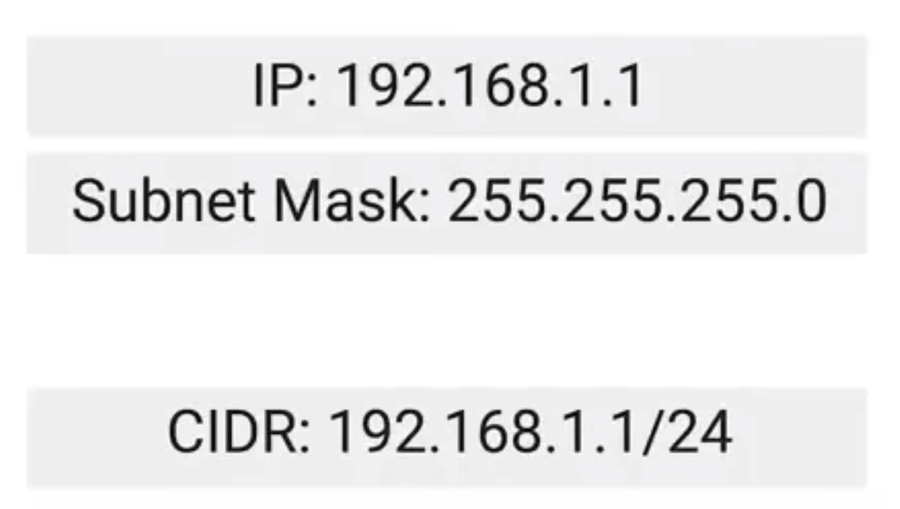

Next Hop:

The next router that should receive the data intended destination address requested.

Total Hops:

Interface:

Router also has to know which of its interfaces it should forward traffic matching the destination address.

**Interior Gateway Protocols:**

**Routing Protocol**

Used to share the information between the router.

Routing protocols fall into two main categories:

Interior gateway protocols

Exterior gateway protocols.

Interior gateway protocols are further classified into two categories:

Link state routing protocols.

Distance-vector protocols.

Interior Gateway Protocol:

Used by routers to share information within a single autonomous system.

Autonomous system:

A collection of networks that fall under the control of a single network operator.

Distance Vector Protocol:

In computer science, a list is known as Vector.

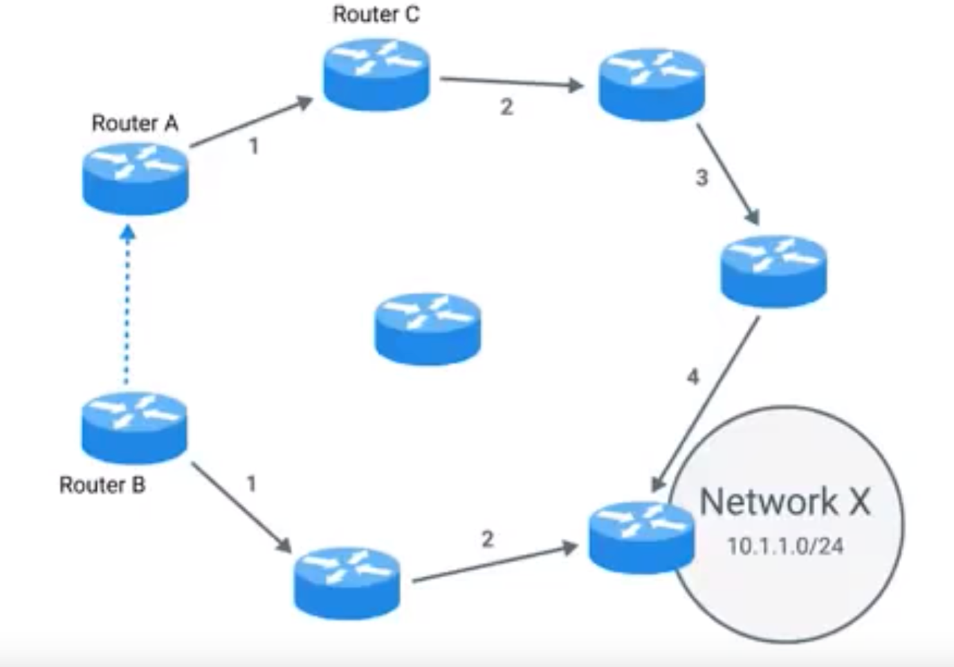

Link state protocol:

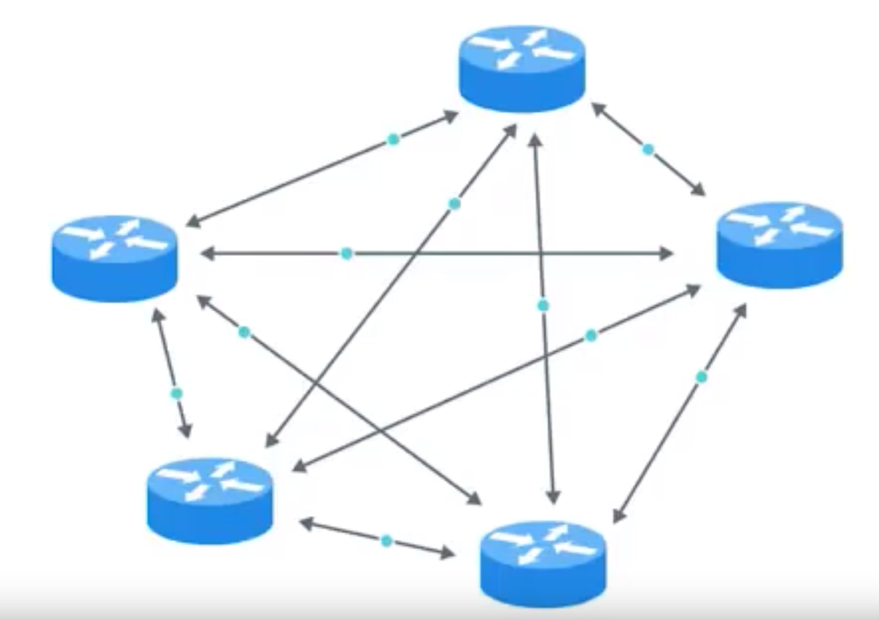

**Exterior Gateway Protocols:**

Exterior gateway protocols are used to communicate data between routers representing the edges of the autonomous system.

Used to share information across different organization.

Routers should know the address of autonomous system to route the traffic. Autonomous systems are known and defined collections of network, getting data to the edge router of autonomous system is the primary goal of the core internet routers.

**Internet Assigned Numbers Authority (IANA)**

A non-profit organization that helps manage things like IP address allocation.

Along with managing IP address allocation, the IANA is also responsible for ASN, or Autonomous System Number allocation.

ASN: Numbers assigned to individual autonomous systems.

ASN is a 32 bit length number, but it is not represented in dotted notation. It is a decimal number.

As like IP address ASN doesn’t have network identifier and host identifier.

Example: AS19604 = IBM

**Non-Routable Address Space:**

Initial days of internet, the total number of unique IP address available was

4, 294, 967, 295

But now there 7.5 billion peoples on earth.

This means that the IPv4 standard doesn’t even have enough IP addresses available for every person on the planet.

RFC -> Request For Comments

RFC – 1918 defined Non-routable address space.

Those are list of IP addresses within a range, will not be routed to the gateway (cannot forward or receive traffic through internet).

RFC-1980 defined three ranges of IP address that will never be routed anywhere by core routers.

Ranges:

10.0.0.8/8

172.16.0.0/12

192.168.0.0/16

These ranges are free for anyone to use for their internal network.

* **The Transport and Application Layers:**

Transport Layer: Allows traffic to be directed to specific network applications.

Application Layer: Allows these applications to communicate in a way they understand.

Transport Layer:

The transport layer has the ability to multiplex and de-multiplex the which sets this layer all other apart from this.

Multiplexing:

Multiplexing in the transport layer means that nodes on the network have the ability to direct traffic toward many different receiving services.

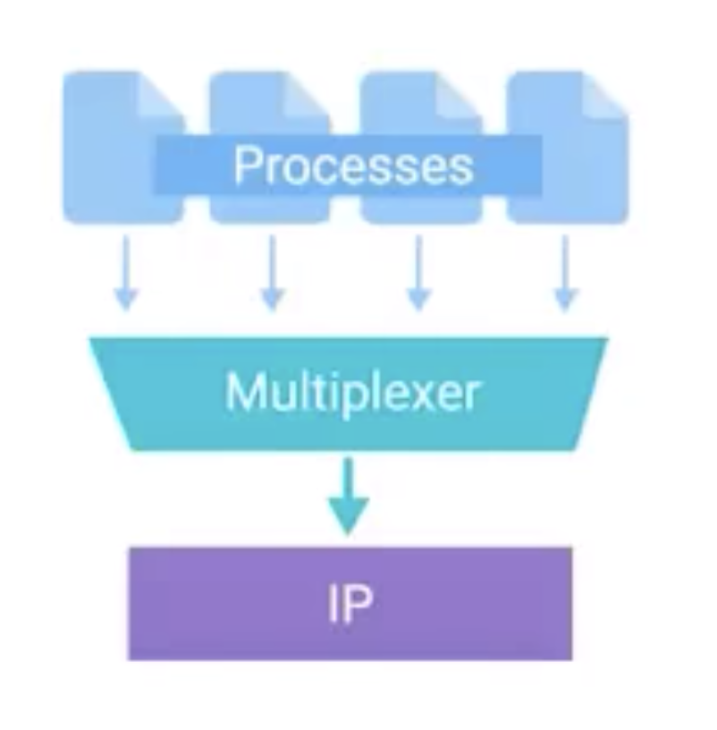

De-Multiplexing:

It is same as multiplexing but this will happen at receiving end. It will take traffic all end at the same node, and delivering it to the proper receiving service.

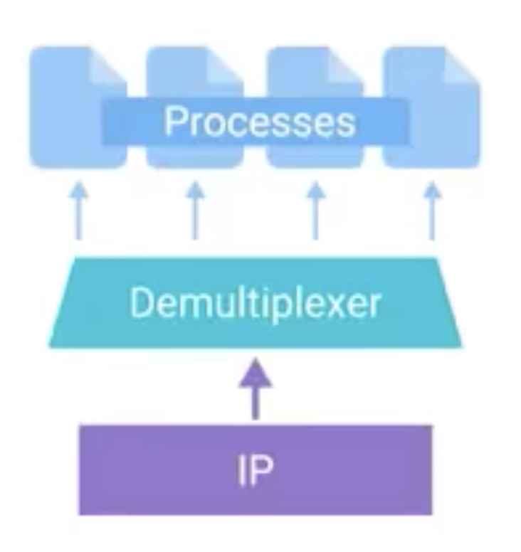

The transport layer handles multiplexing and de-multiplexing through ports.

Port:

A 16-bit number that’s used to direct traffic to specific services running on a networked computer.

The port number for requesting unencrypted web traffic is 80.

10.0.0.100:80 is called as “Socket address” or “Socket Number’.

FTP works on port 21.

In a small company a single server hosts all of the services to run a business.

That server will run mail service, printer service, web pages etc. This is all possible because of multiplexing and de-multiplexing.

**Dissection of TCP Segment:**

**TCP Segment:**

Made up of a TCP header and a data section.

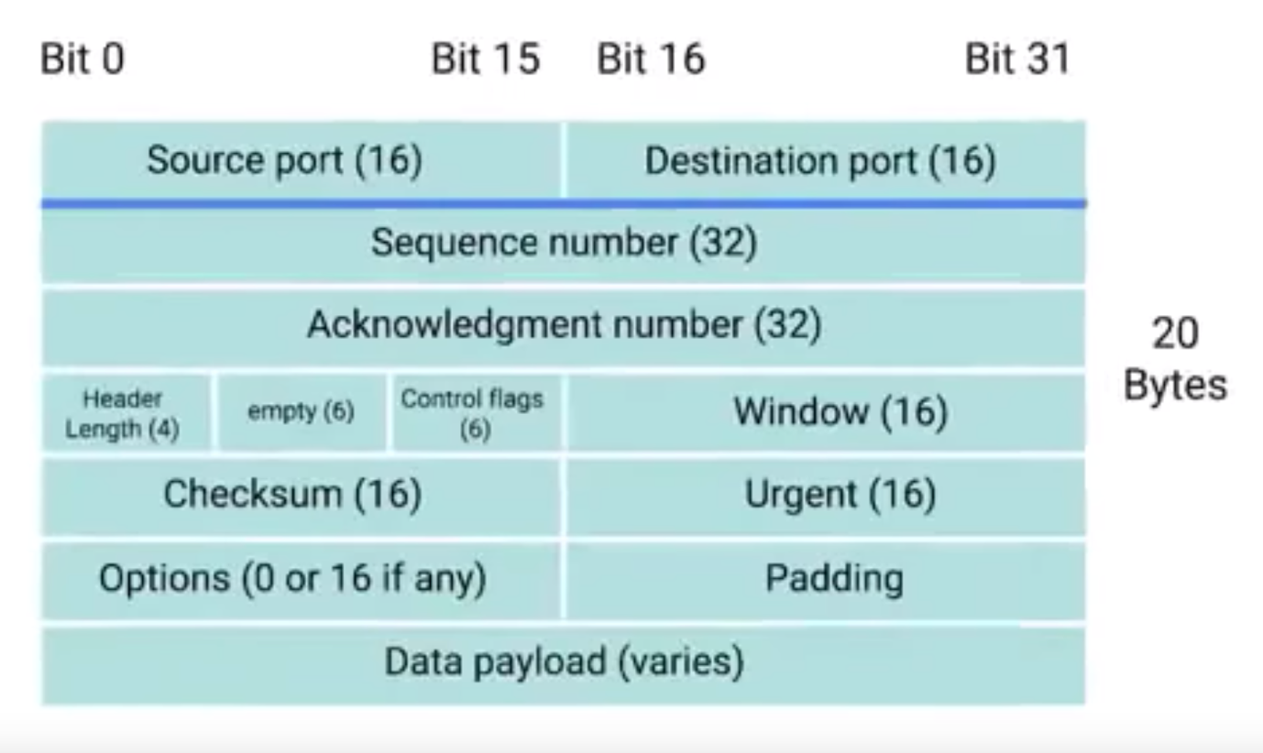

**TCP control-flags and Three-way handshake:**

**URG:**

A value of one here indicates that the segment is considered urgent and that the urgent pointer field has more data about this.

**ACK:**

A value of one in this field means that the acknowledgement number field should be examined.

**PSH:**

The transmitting device wants the receiving device to push currently-buffered data to the application on the receiving end as soon as possible.

**RST:**

One of the sides in a TCP connection hasn’t been able to properly recover from a series of missing or malformed segments.

**SYN:**

It is used when first establishing a TCP connection and makes sure the receiving end knows to examine the sequence number field.

**FIN:**

When this flag is set to one, it means the transmitting computer doesn’t have any more data to send and the connection can be closed.

How connection opened in TCP:

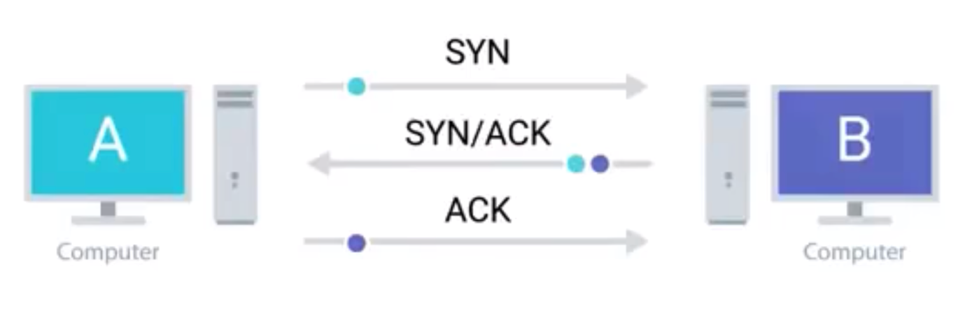

This is also called as “Three way handshake”.

Handshake:

A way for two devices to ensure that they are speaking the same protocol and will be able to understand each other.

Once the three way handshake is done, the TCP connection is established.

**How to close a TCP connection?**

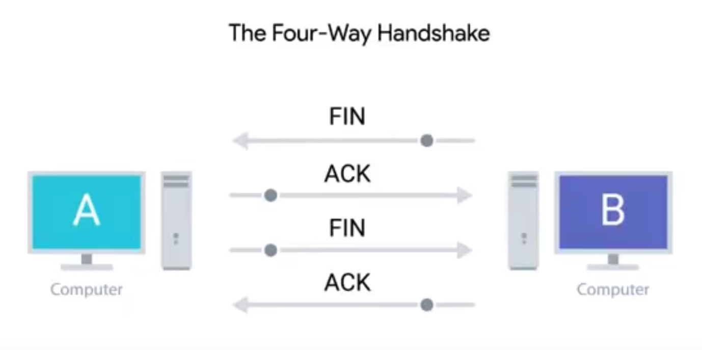

**Socket states:**

**Socket:**

The initiation of an end-point in a potential TCP connection.

**Instantiation:**

The actual implementation of something defined elsewhere.

TCP Socket:

We can get the response from a service port when a socket is opened.

List of socket states:

**LISTEN: (Server side)**

A TCP socket is ready and listening for incoming connections.

**SYNC_SENT: (Client side)**

A synchronization request that has been sent, but the connection hasn’t been established yet.

**SYNC_RECEIVED: (Server side)**

A socket previously in a LISTEN state has received a synchronization request and sent a SYNC/ACK back.

**ESTABLISHED: (Client & Server side)**

The TCP connection is in working order and both sides are free to send each other data.

**FIN_WAIT:**

A FIN has been sent, but the corresponding ACK from the other end hasn’t been received yet.

**CLOSE_WAIT:**

The connection has been closed at the TPC layer, but that the application that opened the socket hasn’t released its hold on the socket yet.

**CLOSED:**

The connection has been fully terminated and that no further communication is possible.

**Connection oriented and connection less protocol:**

Connection-oriented protocol:

Establishes a connection, and uses this to ensure that all data has been properly transmitted.

**Firewall:**

A device that blocks traffic that meets certain criteria.

Firewall can operate at different layers at network.

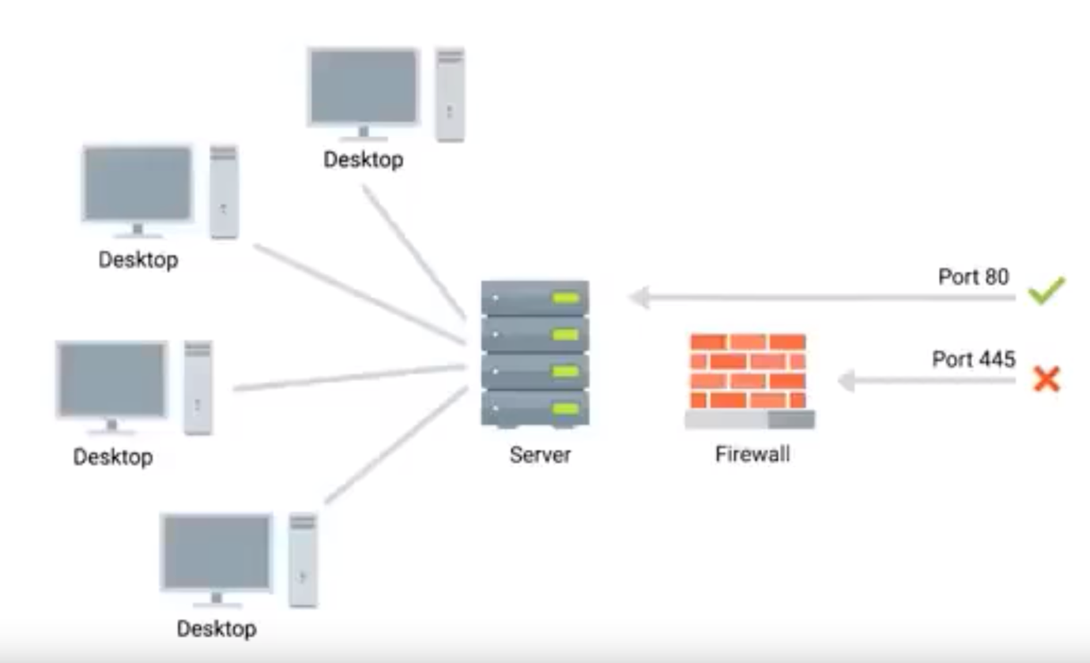

In many cases both router and firewall acts as a same device.

Modern operating system have firewall built-in. In this case blocking of certain traffic can be done at host level itself.

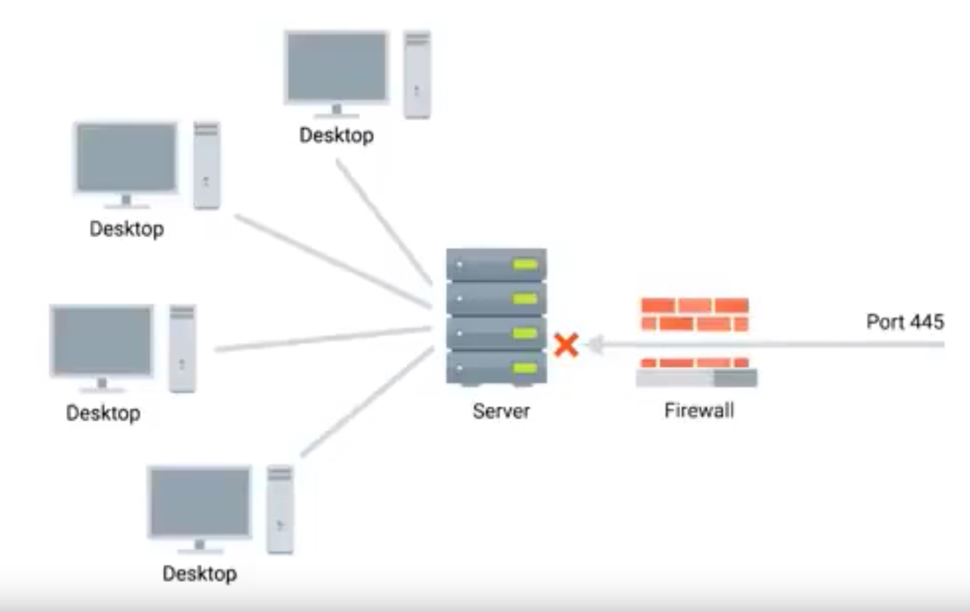

**Application Layer:**

The following are the some of application layer protocols.

HTTP, FTP, SMTP etc.,

**OSI Model:**

OSI model has 7 layers, following are the additional layers when compare to basic model “session and presentation” layer.

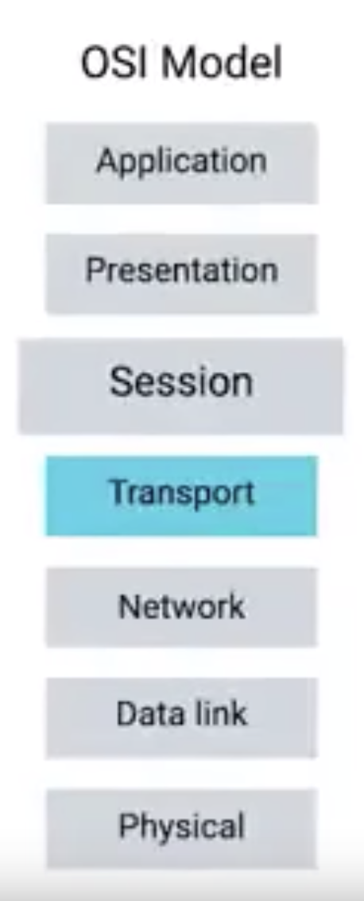

Session Layer:

Facilitating the communication between actual applications and the transport layer.

Presentation Layer:

Responsible for making sure that the unencapsulated application layer data is able to understood by the application in question.

How the overall layers will work to get the response from a server:

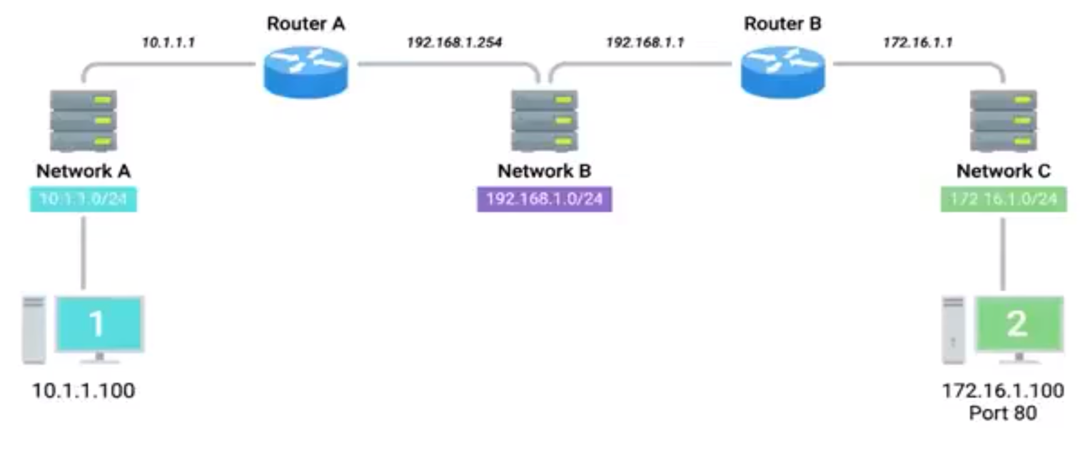

User from computer-1 wants to access an web service which in running on IP address 172.16.1.100 on port 80 and network C.

User from computer-1 opens a web browser and types in the address of webserver which is (172.16.1.100:80)

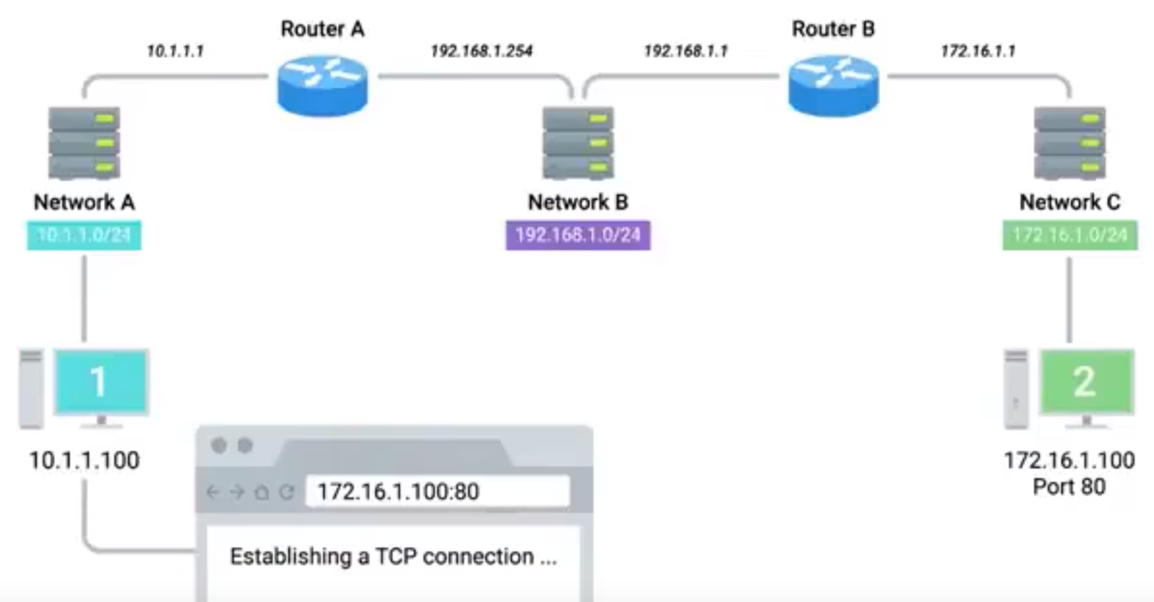

Now the web browser know that it has been ordered to retrieve a web page from 172.16.1.100:80.

Web browser communicates with the local networking stack which is part of the operating system responsible for handling networking functions.

Now the networking stack examines his local subnetting and it founds that it is in 10.1.1.0 and understands the requested IP is on a different network.

At this point computer-1 knows that it has to send the traffic to gateway to routing to a remote network. The router is mapped to IP (10.1.1.1)

Computer-1 looks at its ARP table to determine what MAC address of 10.1.1.1, but it doesn’t find any corresponding entry.

Now computer-1 sends an ARP request to 10.1.1.1, which is sent to the hardware broadcast address of all F’s

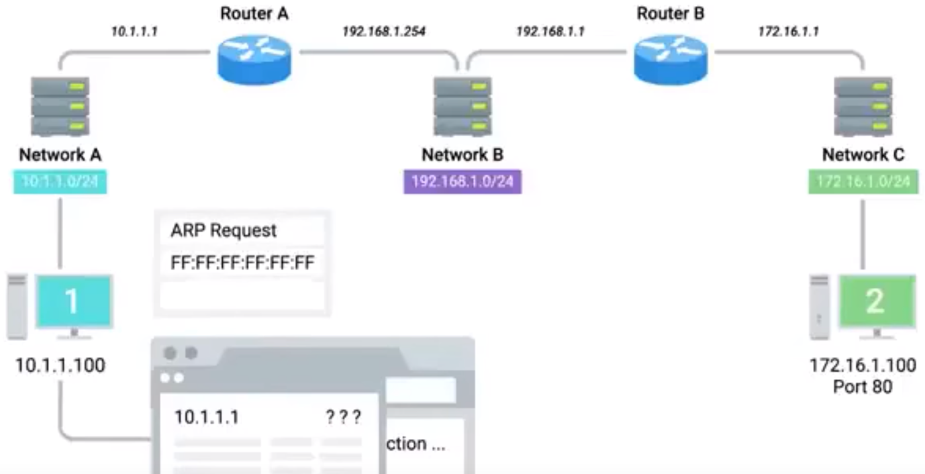

This ARP discovery request is sent to every nodes of the local network.

Now router respond back the MAC address 00:11:22:33:44:55

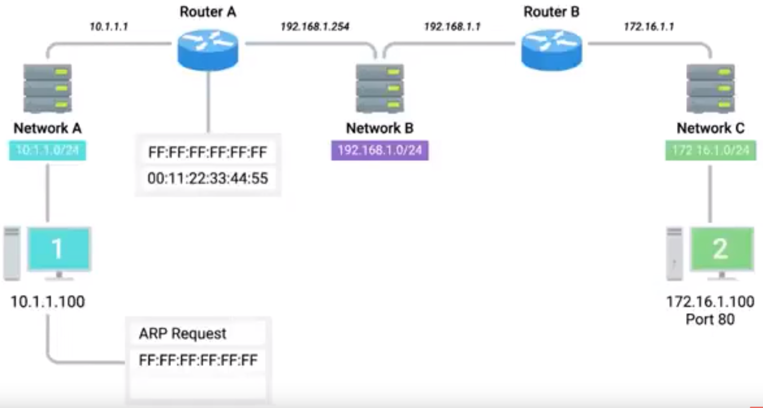

Now the computer-1 knows the MAC address of his router, and it is ready to start constructing outbound packet.

Computer-1 knows that the web browser request to send an outbound TCP connection. Which means it needs an TCP outbound port.

Operating system founds that familiar port 50000 is available and opens a socket to connecting the web browser to this port.

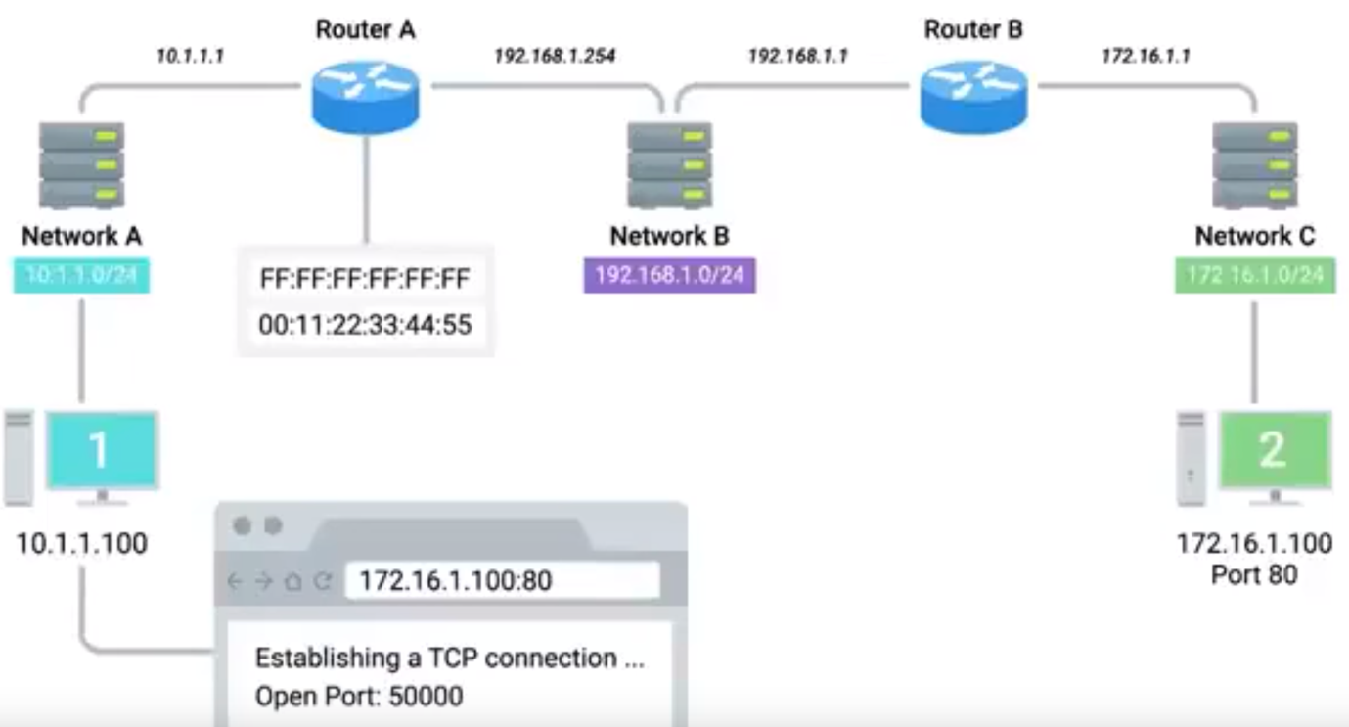

Now the networking stack starts to build a TCP segment, it fill in all the appropriate fields in the segment, including “source port as: 50000” and “destination port as 80”.

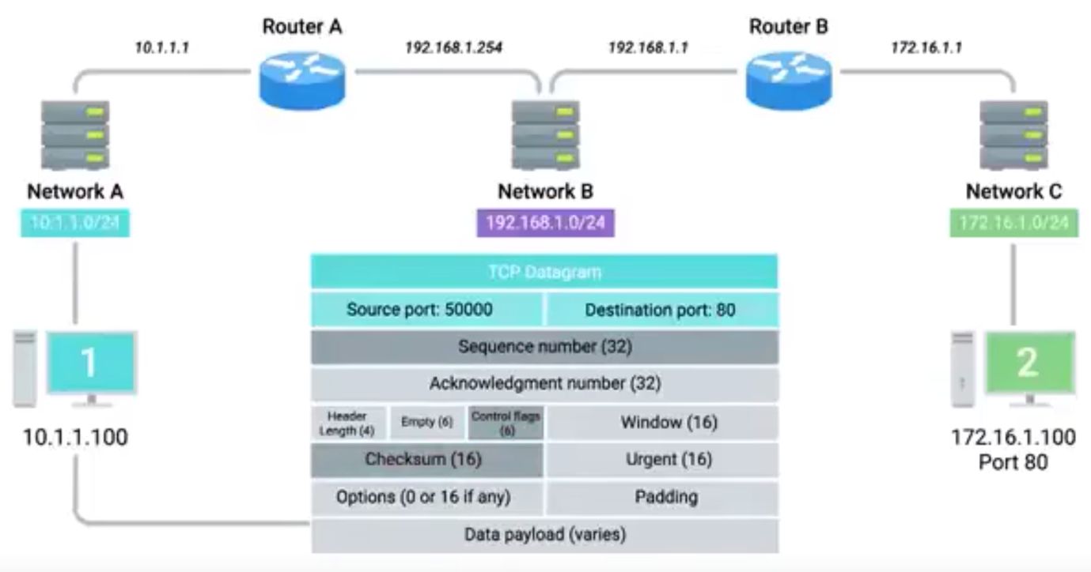

Now the TCP segment, is sent to the IP layer of the networking stack.

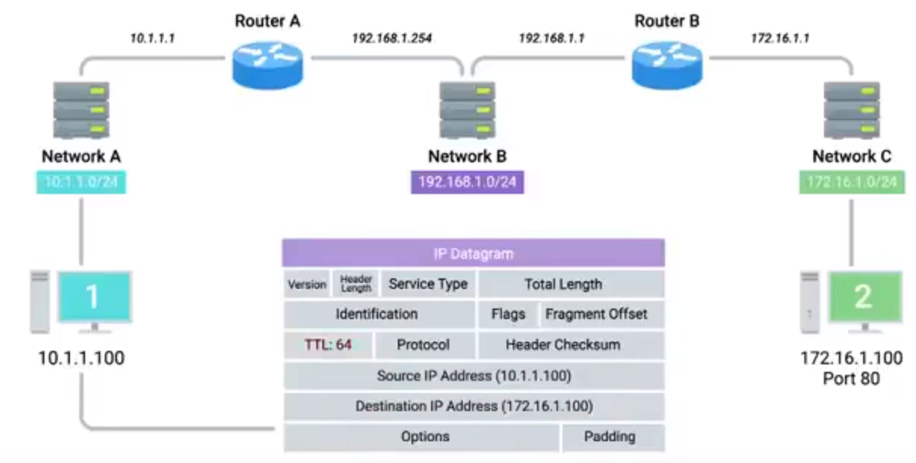

Now it will construct the ethernet datagram

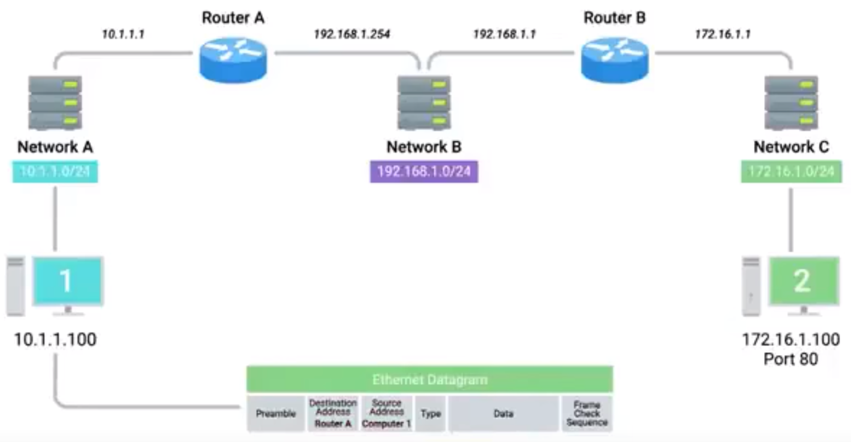

Now the IP datagram is inserted as data payload of the ethernet frame.

Now we have the entire ethernet frame ready to be sent across the physical layer.

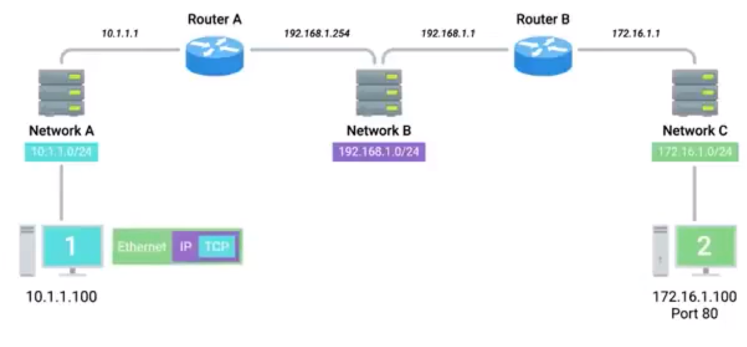

Now this data is sent to the switch and inspects the destination MAC address. The switch knows which of this device has this MAC address and forward the frame to the router.

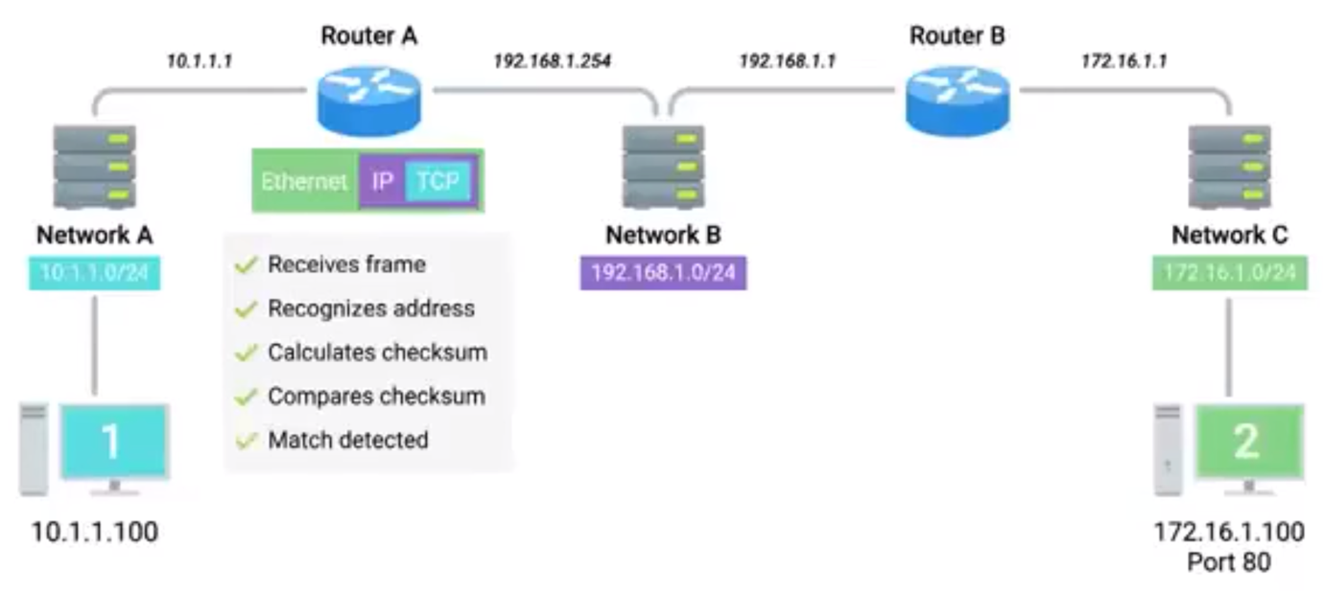

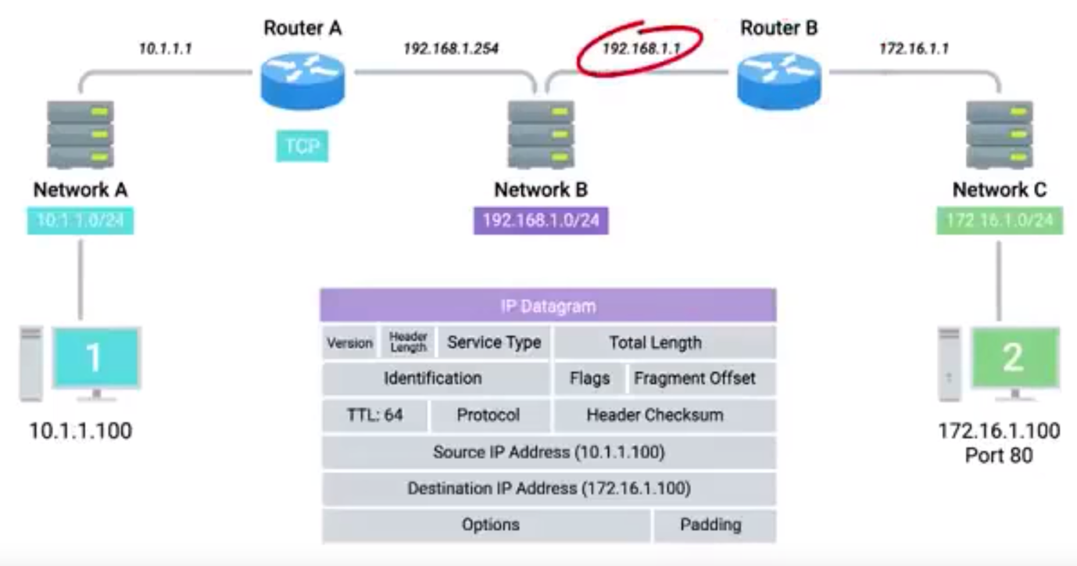

Now router-A checks the MAC address of Router-B in ARP table.

Now router-A constructs an Ethernet datagram by changing the destination address as Router-B and Source address as Router-A.

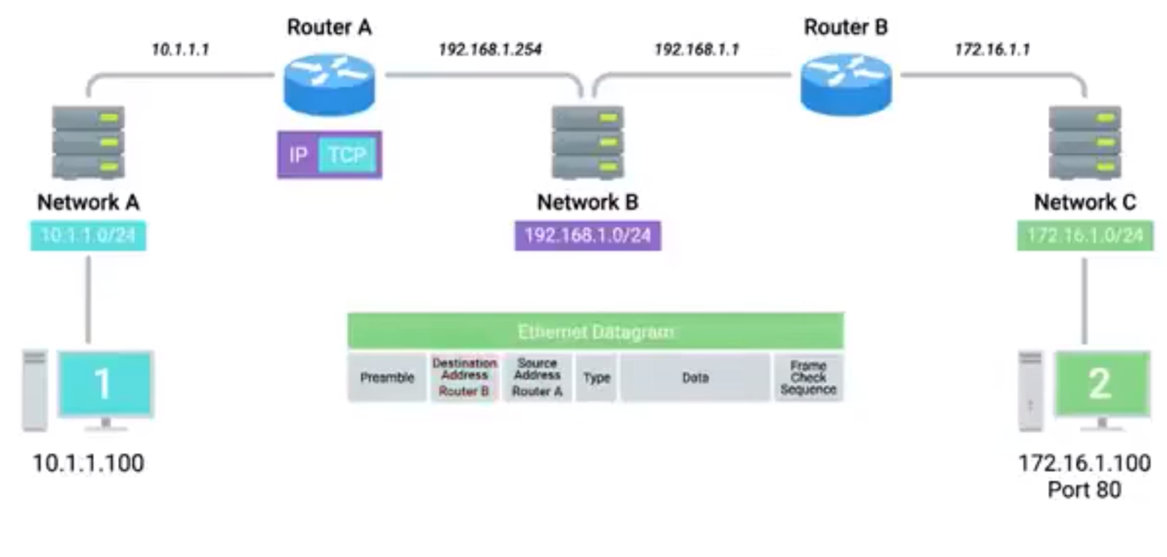

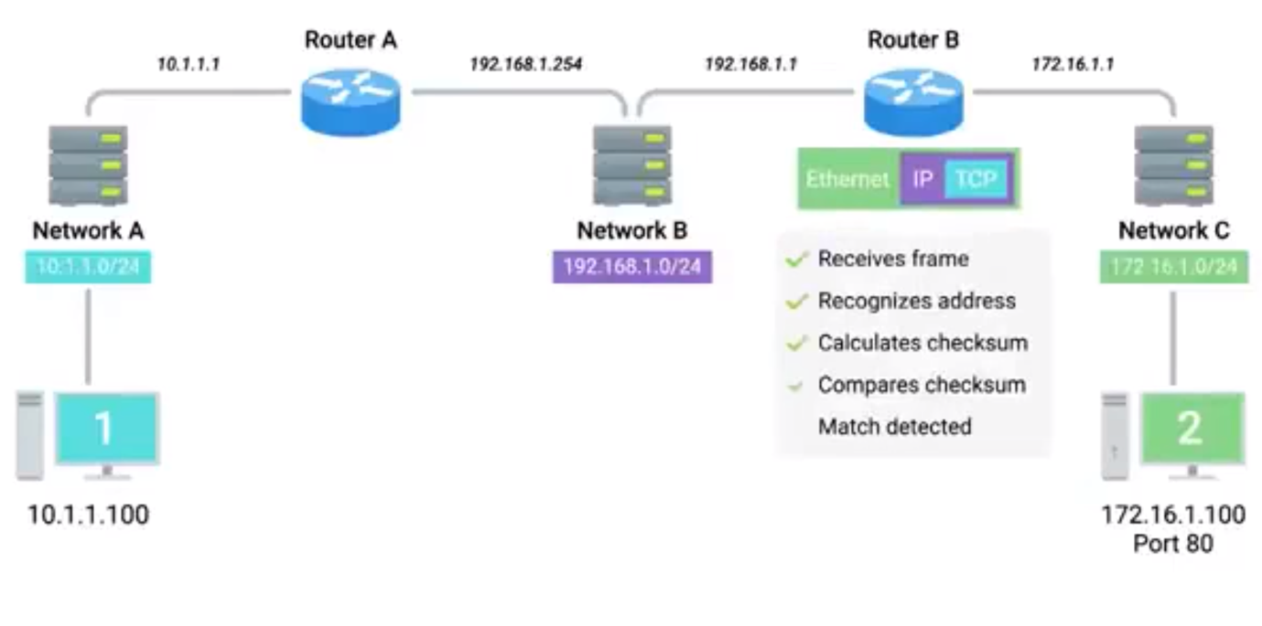

* **Networking Services:**

Why do we need DNS?

DNS = Domain Name System

A global and highly distributed network service that resolves strings of letters into IP addresses for you.

In you want to check a weather online and you can check it on this website [www.weather.com](http://www.weather.com) it will be easy to remember this when compare to remembering the IP address of this site which is 184.29.131.121

Domain Name:

The term we use for something that can be resolved by DNS.

The IP address of the weather.com may changes for any reason, one of them could be, they will be moving to a new data centre or a new cloud provider etc. End user won’t get to know about this as the domain name doesn’t change.

DNS helps in finding the closest server or region.

**The many steps of name resolution:**

DNS changes the domain to an IP address, this process is called Name Resolution.

The following things should be set on a node to properly work on a network.

IP Address

Subnet Mask

Gateway for a host

DNS server

There are five primary types of DNS servers:

1. Caching name servers.
2. Recursive name servers.
3. Root name servers.
4. TLD name servers.
5. Authoritative name servers.

Caching and Recursive name servers: (ISP or local network provider)

Purpose is to store known domain name lookups for a certain amount of time.

Recursive name servers:

Perform full DNS resolution requests.

Let’s say you and your friend are trying to access facebook. Your friend first types in the domain name.

Whenever a domain name is requested in browser it will go to the Caching/Recursive name server.

If the server finds a mapping in the cache it will return the IP, else it will perform a lookup, once it found the IP it will return the IP and put it on the local cache.

After you friend, you are trying to access the same domain, now the caching/ recursive name server found the mapping on cache, hence it will not do any lookup, it will return the IP from the cache. With the help of Caching / Recursive name server, no need to do a lookup again and again for a same domain address.

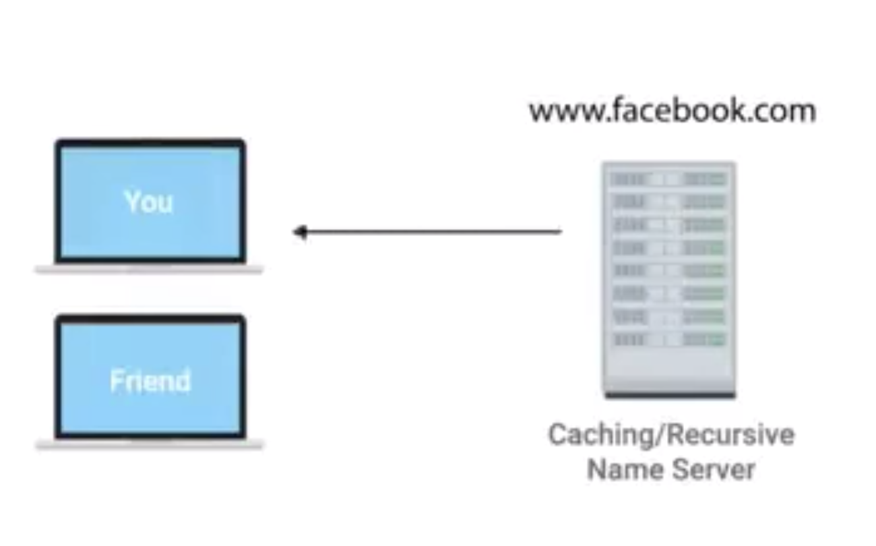

All the DNS server has TTL value:

A value, in seconds, that can be configured by the owner of a domain name for how long a name server is allowed to cache an entry before it should discard it and perform a full resolution again.

Anycast:

A technique that’s used to route traffic to different destinations depending on factors like location, congestion, or a link health.

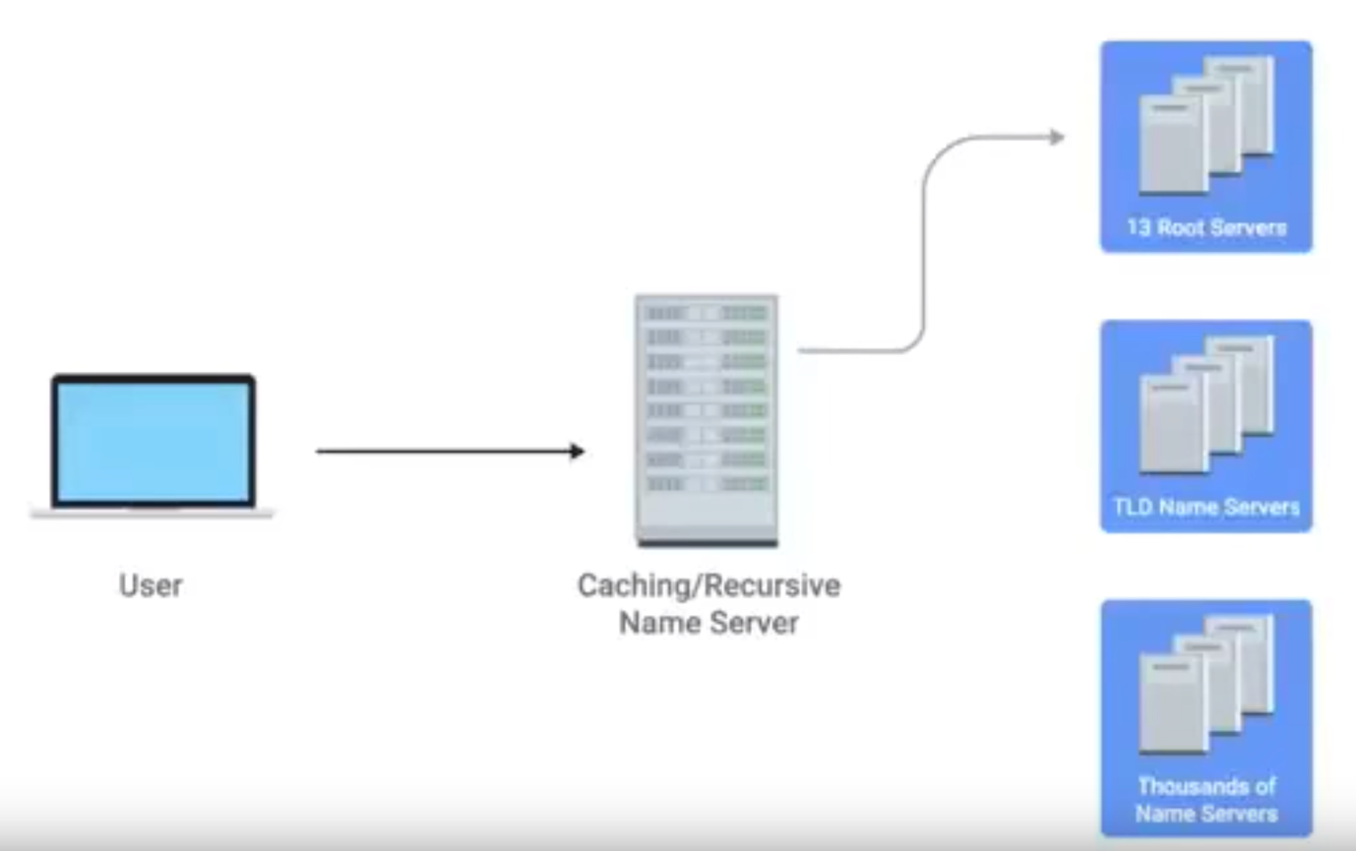

13 root servers or 13 authorities

TLD – Top Level Domain.

Is the last portion of the domain name, in case of [www.facebook.com](http://www.facebook.com)

.com is the TLD.

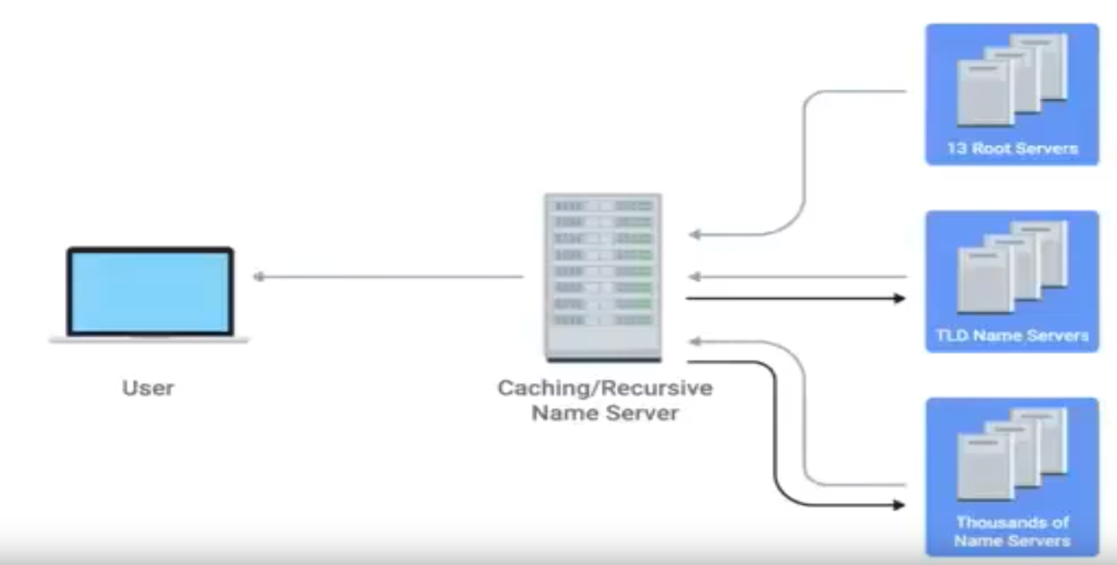

**DNS and UDP:**

DNS uses UDP for the transport layer instead of TCP.

The following are the reason for it.

UDP is connectionless - which means no setup and tear down for this.

In case of TCP, for a single connection, it has to send a three request (3 way handshake).

Number of packets in case of TCP for a single domain resolution.

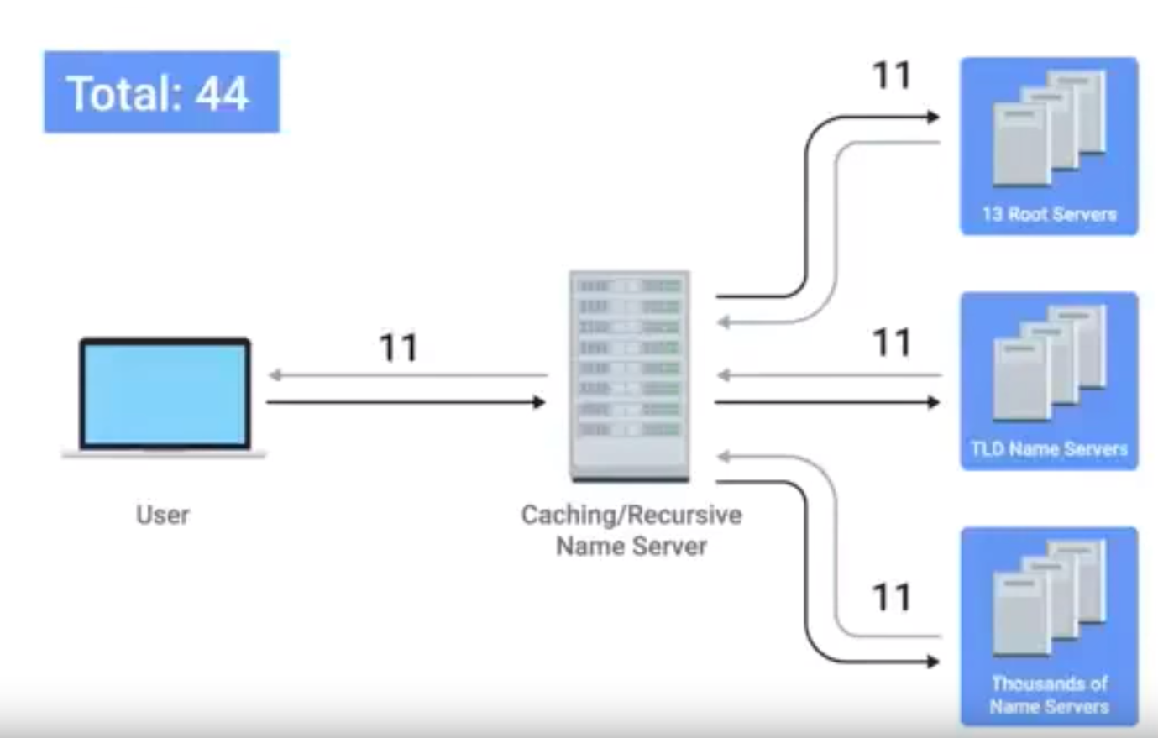

Number of packets with UPD:

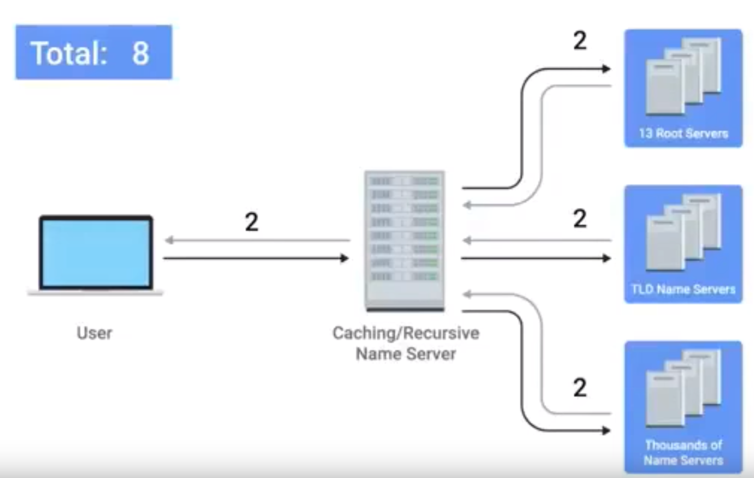

**Resource Record Types:**

An A record is used to point a certain domain name at a certain IPv4 IP address.

AAAA – Quad A -> used for IPv6

A CNAME record is used to redirect traffic from one domain to another.

MX record – Mail Exchange -> used to deliver emails to the correct server.

SRV record – Service record. -> Used to define the location of various specific services.

TXT record – text -> used for configuration preferences for network services.

**Anatomy of DNS:**

Any domain name will have three parts:

[www.google.com](http://www.google.com)

Last part of the domain name (.com) is called TLD (Top Level Domain)

Common TLD, .com., .net, .edu and so on.

Country specific: .de for Germany, .in for India

TLD’s are managed by ICANN ( The Internet Corporation for Assigned Names and Numbers)

ICANN is a sister organization of IANA.

Domains: (google in www.google.com)

Used to demarcate where control moves from a TLD name server to an authoritative name server.

Subdomain: (www in [www.google.com](http://www.google.com))

When we combine all the three parts what we get is called fully qualified domain name.

The company that has an agreement with ICANN can sell domain names.

DNS can technically support up to 127 levels of domain in total for a single fully qualified domain name.

Each individual letters can be 63 characters long. Complete FQDN is limited to a total of 255 characters.

**DHCP:**

An application layer protocol that automates the configuration process of hosts on a network.

With DCHP a machine can query a DHCP server when the computer connects to the network and receives the networking configuration in one go.

Dynamic Allocation:

A range of IP addresses is set aside for client devices and one of these IPs is issued to these devices when they request one.

Automatic Allocation:

A range of IP addresses is set aside for assignment purpose.

Fixed allocation:

Requires a manually specified list of MAC address and their corresponding IPs.

We can use DHCP servers for NTP.

Network Time Protocol Servers:

Used to keep all computers on a network synchronized in time.

**DHCP in Action:**

DHCP is an application layer protocol, which relies on the Transport, Network, Datalink and Physical layers to operate.

Main use of DHCP is to help configure the network layer itself.

DHCP discovery:

The process by which a client configured to use DHCP attempts to get network configuration information.

DHCP listens on UDP port 67

DHCP discovery message are always sent from port 68

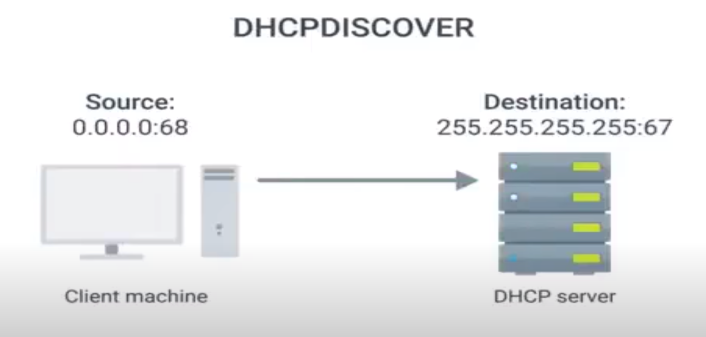

For DHCP discover message, DHCP server respond back the DHCP offer. It will pick the IP address based on fixed, dynamic or automatic.

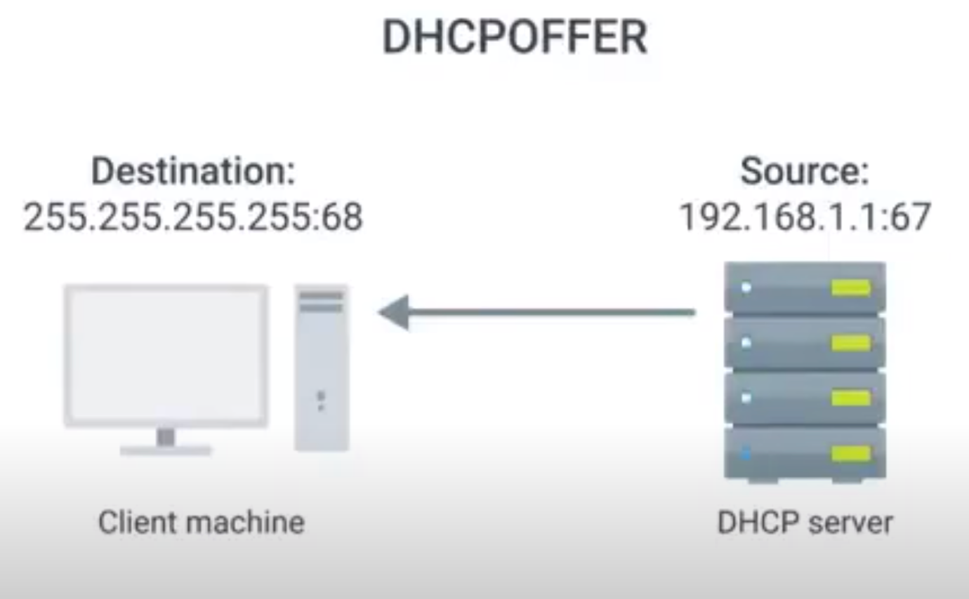

Since the DHCP offer message is a broadcast, it will reach every machine on the network.

The DHCP discover message sent by the client would know that the DCHP offer is for them, as the DHCP offer has a field which contains the MAC address of the client which sent the DHCP discover.

Now DHCP client will send a DHCPREQUEST to DHCP SERVER saying that I’m accepting the IP addressed you assigned.

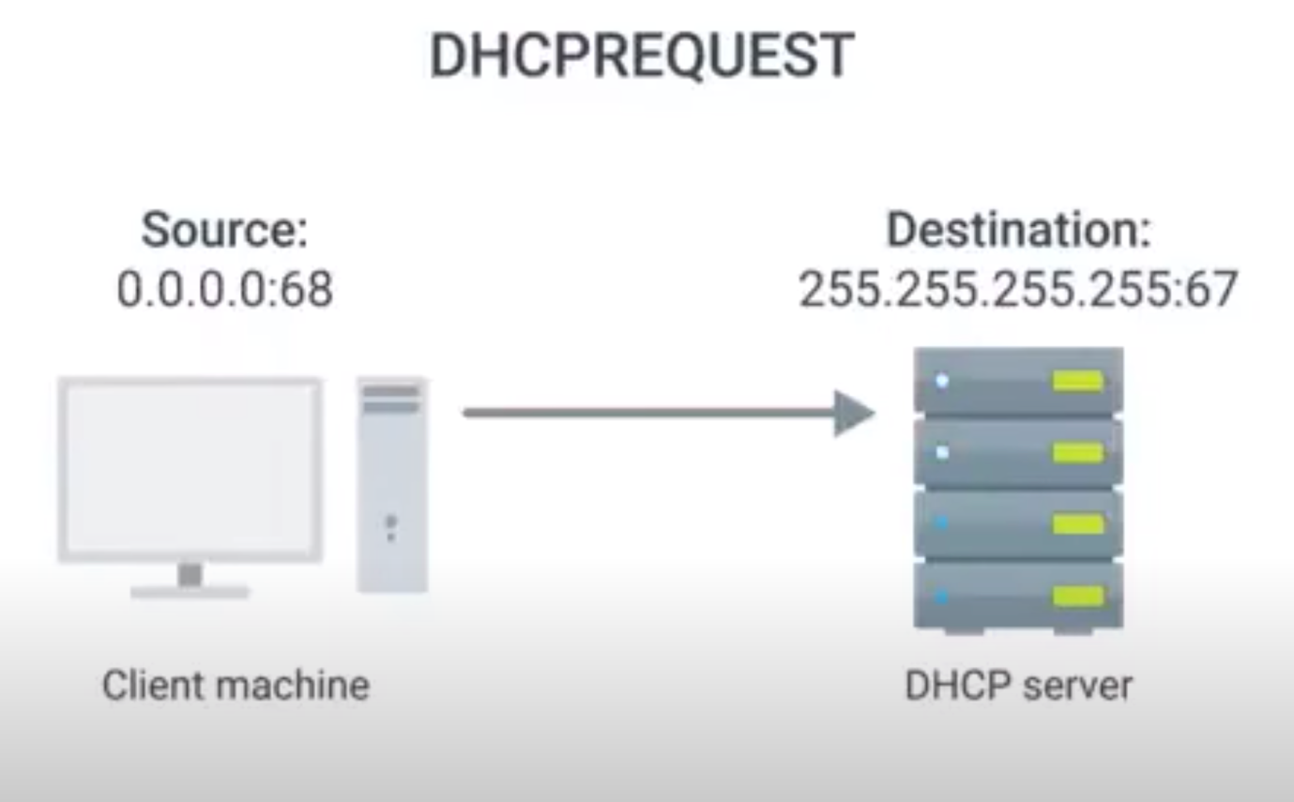

Finally DHCP server will send an acknowledgment message.

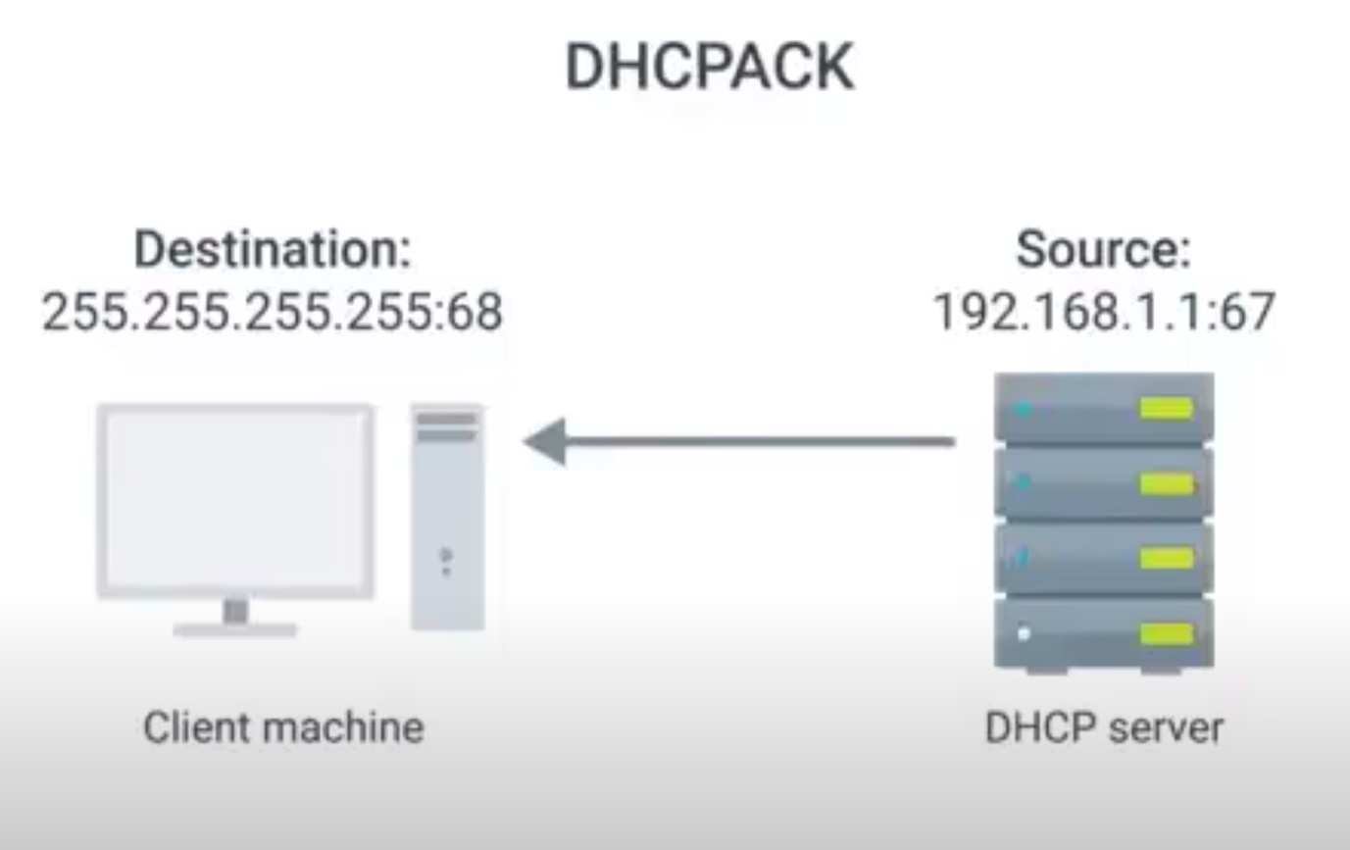

After the acknowledgment message, the client system can start functioning in the network.

All of this configuration is a DHCP lease as it includes an expiration time.

A DHCP lease may exists for a days or short amount of time.

If the lease is expired again the client machine has to negotiate with DHCP server to get the DCHP lease again, which would go through the same set of process.

As like lease expiring, the client machine has release the lease, so that the DHCP server can put the IP address back to the pool, it will be assigned to another client.

**Basics of NAT:**

NAT is a technique instead of a defined standard.

It takes one IP address and translates it to another IP address.

The reason behind doing NAT, security safeguard to preserving the limited amount of available IP V4 space.

Network Address Translation:

A technology that allows a gateway, usually a router or firewall, to rewrite the source IP of an outgoing IP datagram while retaining the original IP in order to rewrite it into the response.

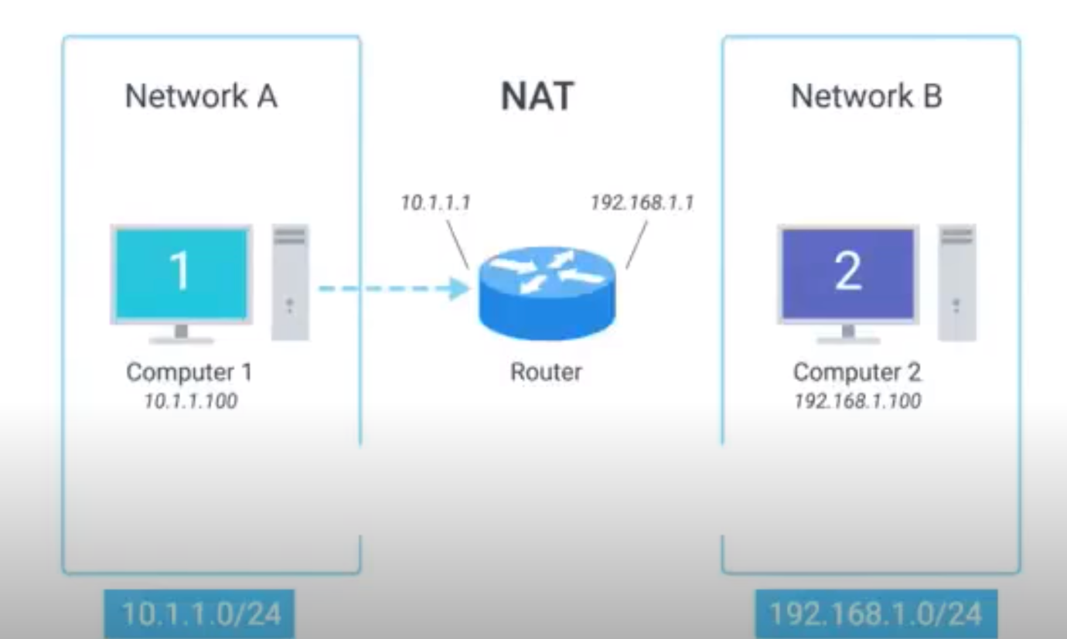

In case of NAT, router will rewrite the source IP address (to

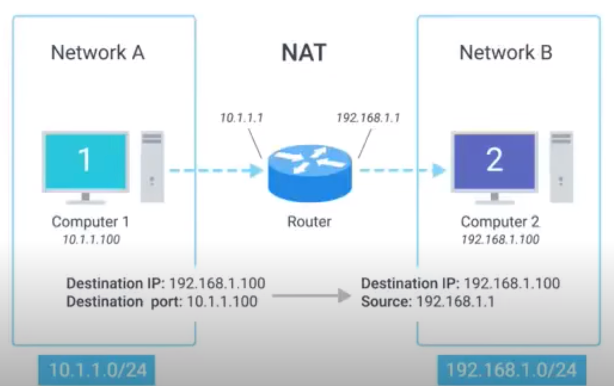

NAT is hiding the IP from computer-1 to computer-2 this is known as IP masquerading.

IP – masquerading is important security concept. The basic concept apply here is that no one can establish a connection to your computer if they don’t know what IP address it has.

By using NAT they way we just described, we could have 100’s of computer on network-A all of their IP is translated by the router. The outside world, the entire address space of network-A is protected and invisible. This is known as one-to-may NAT.

**NAT and the Transport Layer:**

In case of NAT the outbound is pretty simple to process, whereas in case of inbound traffic, it will be bit complex as we have to map the response to the correct machine which made a request.

The above problem is solved by Port preservation.

Port preservation:

A technique where the source port chosen by a client is the same port used by the router.

In case of port preservation, whenever router translates the source IP address, it saves the port of the request (port of the networking stack request).

Once the router receives a response back, it will check the port and it knows that it has to be redirected to specific machine.

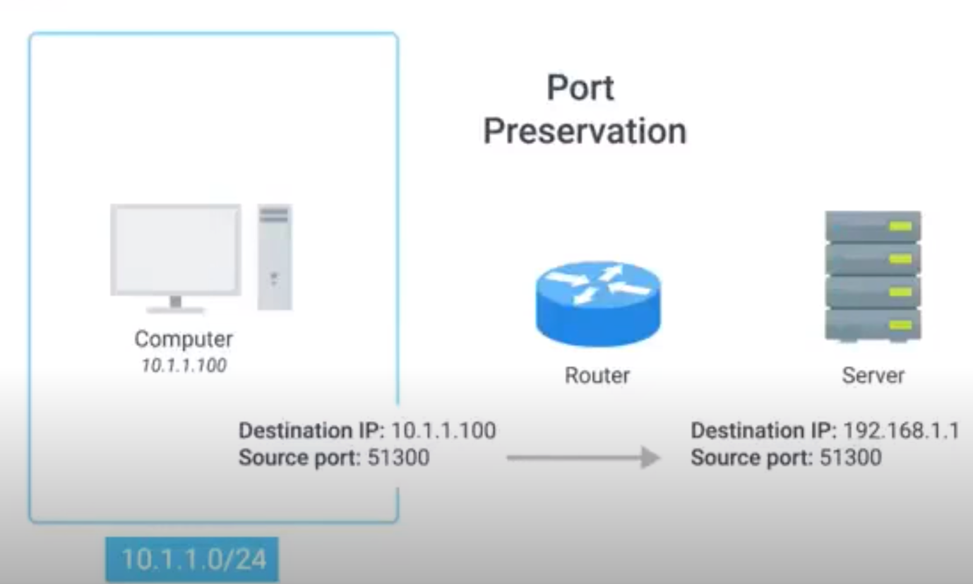

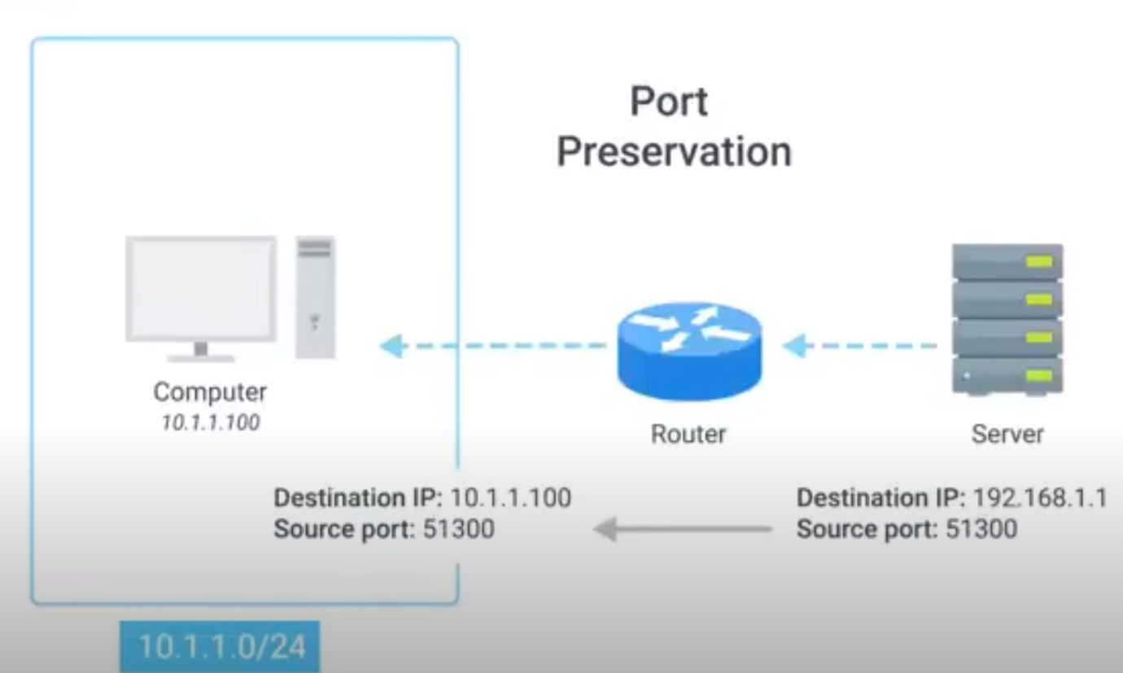

There is a chance of using the same port on the two different nodes, if this happens router always try to choose the unused ports.

**Port Forwarding:**

A technique where specific destination ports can be configured to always be delivered to specific nodes.

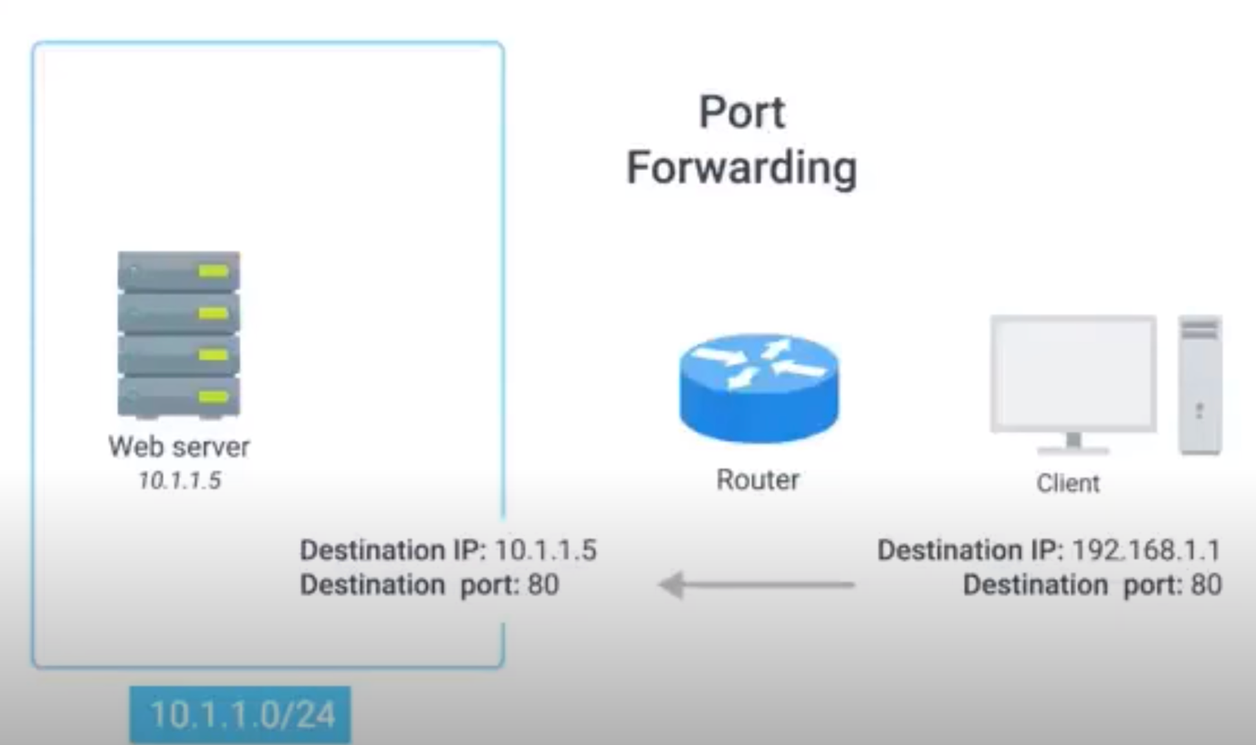

This technique not only allows for IP- masquerading, it also simplifies how external users might interact with lots of services all run by the same organization.

Lets say a company is running webserver and mail server with two different IP, with port forwarding we can use the same external IP to access both the service just by changing the port number.

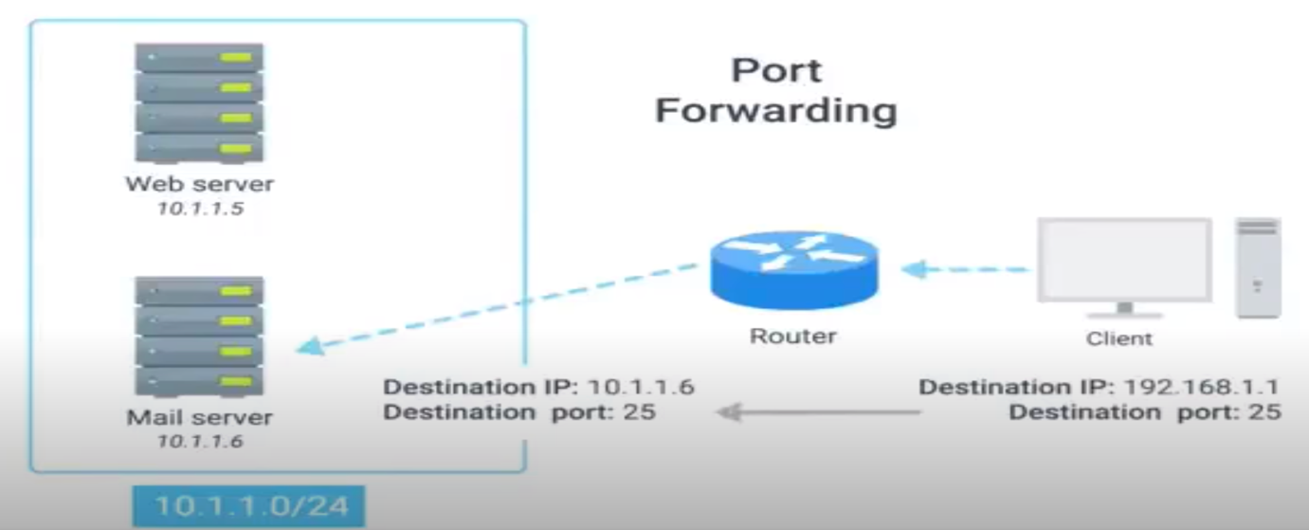

**NAT, Non-Routable Address space, and limits of IPv4:**

Regional internet registries.

AFRINIC

ARIN

APNIC

LACNIC

RIPE

IPv4 addresses are almost exhausted, to overcome this issue we can use IPv6 or NAT or non-routable address space. With NAT with single static IP for router we can forward and receive traffic for 100s of system.

**Virtual Private Network:**

A technology that allows for the extension of a private or local network to hosts that might not be on that local network.

VPN is a tunnelling protocol.

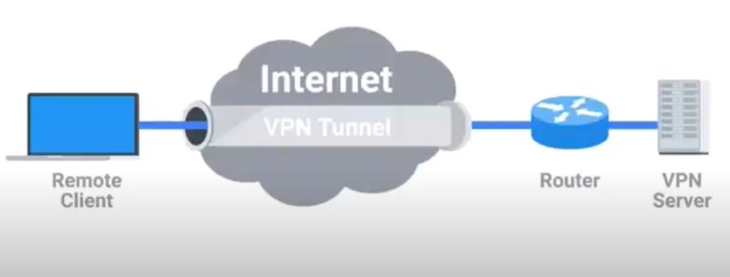

Whenever we use VPN, the data is encrypted before sending it to the destination, at the destination by VPN server, it decrypts the data and send it to the specific node.

Two-factor authentication:

A technique where more than just a username and password are required to authenticate.

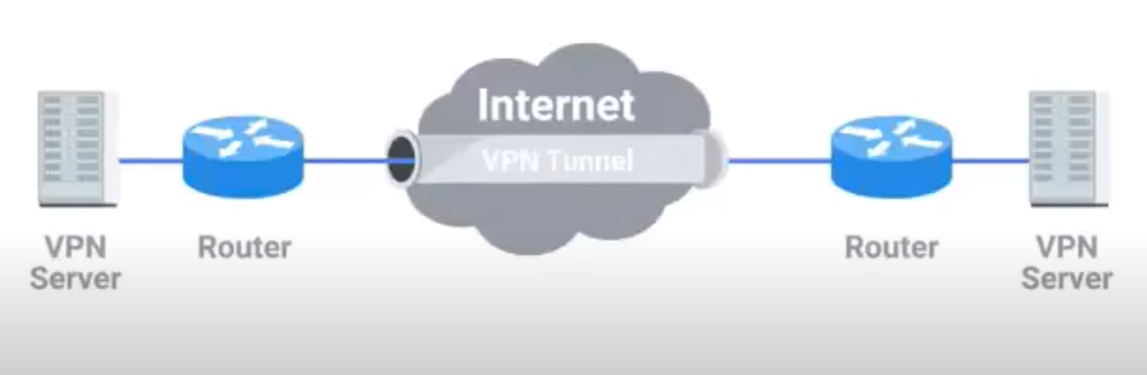

Note: As like NAT, VPN is not a strictly defined protocol, it is just a technique.

VPN’s are a technology that uses encrypted tunnels to allow for a remote computer or network to act as it is connected to a network that is not actually physically connected to.

NAT:

The number of available IP addresses in IPv4 is 4.2 billion address, but this is not enough when compared with population of universe.

NAT is the solution for this problem.

There are two types of IP addresses:

Public (An address which can be accessed through the internet)

Private (An address which can’t be accessed through internet)

The following are the private IP ranges:

192.168.X.X

10.X.X.X

Accessing internet with private IP address:

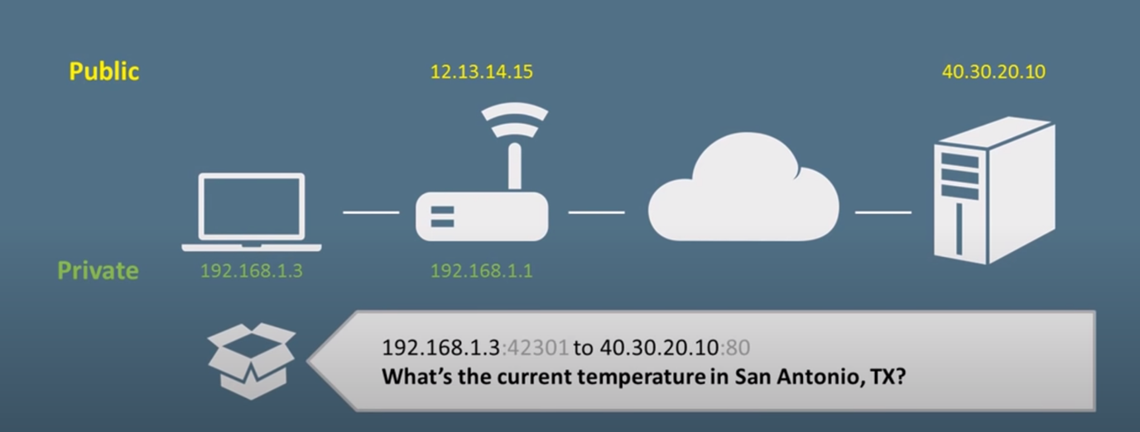

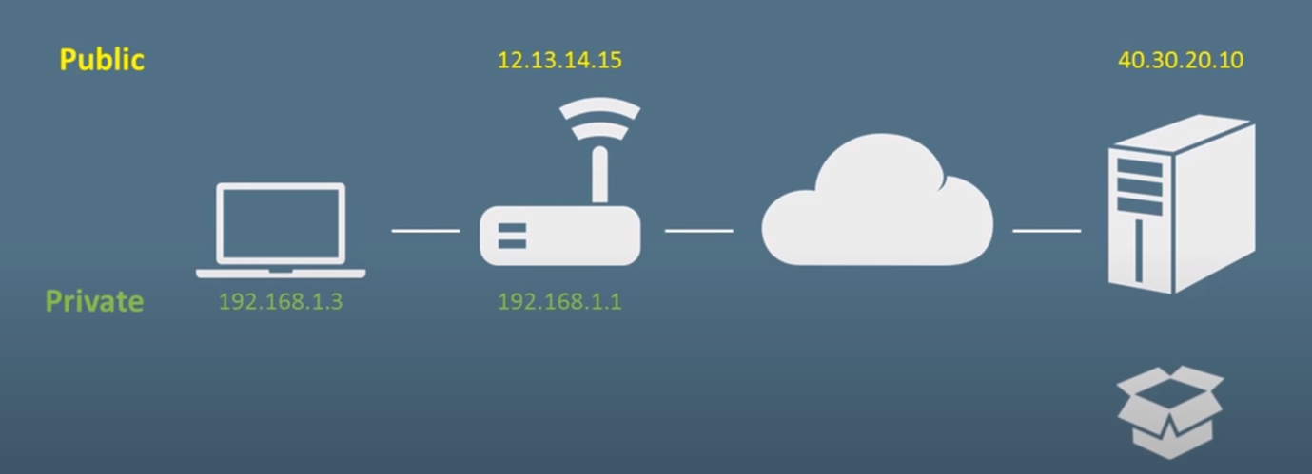

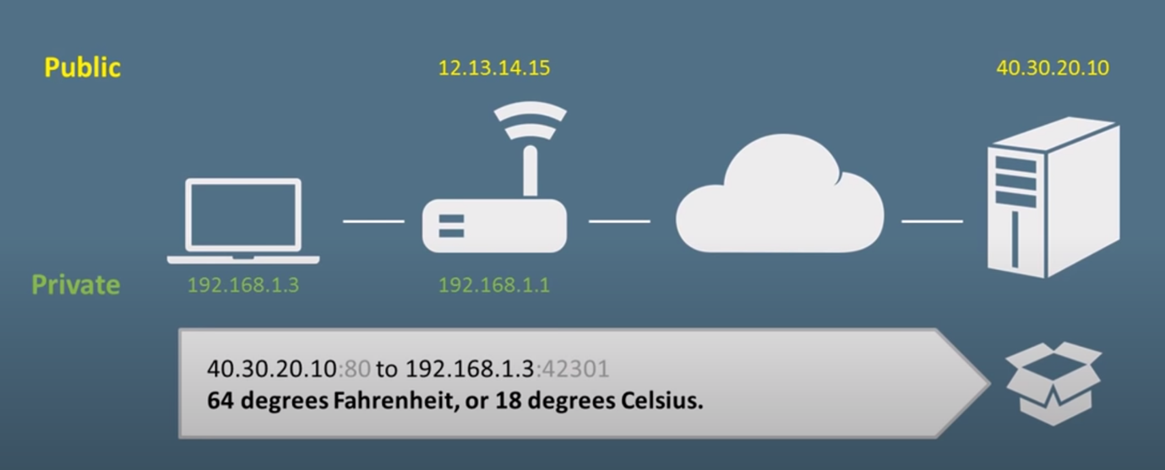

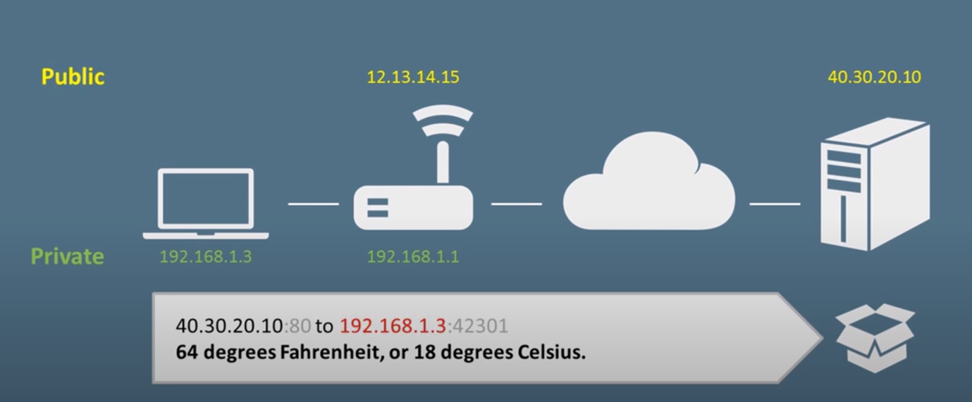

When the web server sends back the address, the source system is not accessible as it has a private IP address.

The same request and response process with NAT:

